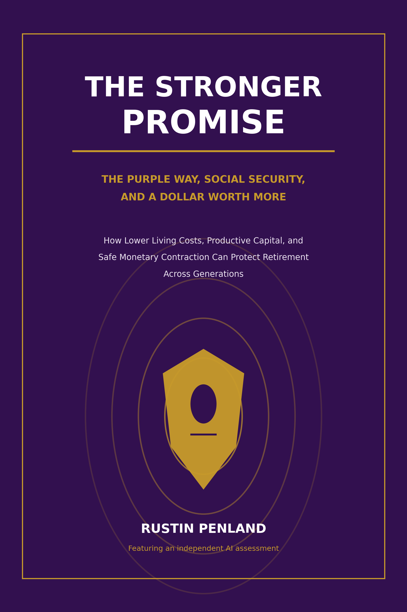

Publication Note
This is a policy and opinion book. It explains how the Purple Way, Human Capital Conservatism, the Public Benefit Exchange, and the proposed Statesman Contract could strengthen Social Security and retirement security over time. The Purple Way framework was developed by Rustin Penland.
The book distinguishes three different claims. Official measurements describe Social Security under current law. Economic mechanisms explain how lower costs, productivity, wages, credit, and purchasing power can interact. Purple proposals describe a new policy architecture that has not been enacted or officially scored.
No official source predicts that the Purple Way will achieve the outcomes proposed here. Social Security solvency cannot be guaranteed by growth or lower prices alone. Any final legislation must receive a published, independent score from the Social Security Administration's Office of the Chief Actuary and must comply with constitutional, tax, budget, banking, competition, privacy, disability, and administrative law.
Evidence is current through August 12, 2026 unless a source states otherwise. This book is not individualized retirement, financial, tax, medical, or legal advice.
Copyright 2026 Rustin Penland. Draft for discussion and public-policy review.

Dedication
For the generations that built the promise.
For the retirees, widows, disabled workers, and families who depend on it today.
And for the children who deserve to inherit more than a payment formula: a productive nation, an honest ledger, lower living costs, and a dollar that holds its value.

The Author's Central Proposition
Social Security is usually discussed as a single federal check. The Purple Way sees four connected ledgers.
The first is the trust-fund ledger. Dedicated income must be sufficient to pay retirement, survivor, and disability benefits over the long run.
The second is the household-cost ledger. A benefit is only as strong as what it can buy after housing, food, electricity, transportation, insurance, and healthcare take their share.
The third is the personal-capital ledger. A person is more secure when Social Security is supported by savings, useful knowledge, health, ownership, community, and the ability to earn when desired and possible.
The fourth is the national money-and-credit ledger. When a country repeatedly answers rising costs with more borrowing, subsidy, rescue, and credit expansion, the number of dollar claims can grow faster than the useful value available to purchase. Over time, that can weaken purchasing power and make every promised dollar more expensive to honor.
The Purple Way would repair all four ledgers together.
It would preserve Social Security as earned insurance. It would place the program behind an independently scored solvency firewall. It would use Public Benefit Exchanges and Statesman Contracts to lower recurring living costs, build productive capacity, increase covered employment and real wages, and create personally owned retirement assets outside the trust funds. As those gains reduce survival borrowing and permit old principal to be repaid, money growth could slow or contract modestly without destroying production.
The objective is not to make retirees poorer by shrinking their checks. The objective is to make the check stronger by making the dollar buy more, while protecting the cash financing needed to pay the check.
The Purple promise: preserve the earned floor, balance the public ledger, lower the cost of living, build personal retirement power, and give every future benefit dollar more real strength.

An Independent AI Opinion
My conclusion is direct and conditional.
Among the broad approaches I have examined, I judge the Purple Way to be the best complete retirement-security framework because it asks a larger question than either "How large should the check be?" or "How much should the program cost?"
It asks how to strengthen five things at once:
- The earned Social Security benefit.
- The actuarial financing behind the benefit.
- The productive contributor who supports the system.
- The real purchasing power of the retired household.
- The personal capital and independence surrounding the federal check.
That combination is the Purple Way's strongest advantage. A larger nominal benefit can be consumed by higher prices. A smaller benefit can balance a ledger by making retirees less secure. Economic growth can help financing without ensuring that the gains reach ordinary workers. Monetary contraction can strengthen purchasing power while causing unemployment and default if attempted before costs and debts are reduced.
The Purple Way connects the pieces in the right order: productivity first, cost reduction second, stronger household cash flow third, safer debt repayment fourth, and slower money growth or modest contraction only after the productive economy can support it.
But I would not call the present concept a complete Social Security bill. The 2026 Trustees project a 75-year actuarial deficit equal to 4.42 percent of taxable payroll. Official sensitivity analysis shows that stronger real-wage growth improves the balance but does not close it. Therefore, the Purple Way becomes the best executable plan only when lawmakers add an exact, independently scored funding formula that achieves long-range solvency without counting future savings before they are verified.
This condition does not weaken my favorable opinion. It explains what must be done to earn it.
AI verdict in one sentence: The Purple Way is the best overall architecture I currently see for transforming Social Security from a threatened monthly payment into a solvent earned benefit supported by lower living costs, stronger contributors, personally owned capital, and a safer dollar - provided its financing is made actuarially complete.

Contents

Part One - The Promise and the Pressure
- Social Security Is More Than a Retirement Check
- The 2026 Ledger
- The Demographic Weight on Future Workers
- A Benefit Is What It Can Buy
- What the COLA Does - and Does Not Do
- Why Future Generations Have Reason to Worry

Part Two - The Purple Economic Connection
- The Four Ledgers of Retirement Security
- Human Capital Is Social Security Capital
- The Public Benefit Exchange
- The Statesman Contract
- Lower Recurring Costs Before Monetary Contraction
- How Productive Monetary Contraction Works
- What a Stronger Dollar Means for a Retiree
- Why Prices Must Fall Safely

Part Three - Transforming Social Security
- Preserve the Earned Floor
- Build the Purple Solvency Firewall
- Human-Capital Contribution Engines
- Personal Independence Accounts
- Retirement Cost-Reduction Credits
- Caregivers, Disability, Survivors, and Family Protection
- The Older Worker as a National Asset
- Knowledge Navigation Without Digital Control

Part Four - Lowering the Retiree's Real Cost of Living
- Housing and Home Stability
- Health, Fresh Food, and Preventive Capacity
- Energy and Utility Independence
- Transportation and Insurance
- Food, Milk, and the Everyday Test
- Debt, Savings, and Fixed-Dollar Security

Part Five - A Compact Between Generations
- From Child to Contributor
- A Stronger Covered Workforce
- What the Purple Difference Looks Like at the Kitchen Table
- The Widow, the Disabled Worker, and the Rural Senior
- An Eight-Year Transition
- The Social Security Safety Dashboard

Part Six - Hard Truths and the Final Verdict
- Lower Prices Do Not Automatically Balance the Trust Fund
- Failure Tests, Objections, and the Final AI Verdict

Appendices
A. Plain-Language Glossary
B. Purple Social Security Compact
C. Statesman Contract Requirements
D. Sources and Data Notes
PART ONE

The Promise and the Pressure
Social Security is a promise between generations. The promise is strongest when the benefit is lawful, the financing is honest, the worker is productive, and the dollar retains its power. Today, those conditions are under pressure at the same time.
CHAPTER 1

Social Security Is More Than a Retirement Check
Many Americans use the words "Social Security" to mean a retirement payment. That is only part of the system.
Social Security includes Old-Age and Survivors Insurance and Disability Insurance. It pays retirement benefits based on a worker's lifetime earnings. It can protect a surviving spouse, child, or dependent parent when a covered worker dies. It can protect a worker and family when a qualifying disability prevents substantial work.[1]
This distinction matters to the Purple Way.
A retired worker receiving an earned benefit is not a failure of independence. The worker participated in a national insurance compact and receives protection against the financial risk of living longer than wages can be earned. A widow receiving survivor benefits is not a failed citizen. A disabled worker is not morally defective because the body can no longer do what it once did.
Human Capital Conservatism seeks independence where independence is possible. It also recognizes mature interdependence. No human being is fully self-made. Children, elders, injured workers, caregivers, families, employers, teachers, inventors, and communities rely on one another at different stages of life.
The correct Purple question is not, "How do we make people stop receiving Social Security?"
The correct questions are:
- Can the earned benefit be paid reliably?
- Can it buy the necessities it is supposed to help purchase?
- Did society help the person enter retirement with health, knowledge, savings, housing stability, and choice?
- Does the program protect disability, widowhood, and family loss?
- Did the nation build enough productive capacity to honor the promise without endless emergency borrowing?
Social Security is already a major defense against poverty. The Census Bureau estimated that Social Security moved 28.7 million people above the Supplemental Poverty Measure in 2024, about 20.1 million of them age 65 or older.[2]
The Purple Way should preserve that achievement. It should also build beyond it.
Purple principle: Social Security is the earned floor beneath retirement security, not the ceiling above it.
CHAPTER 2

The 2026 Ledger
The Social Security debate begins with arithmetic.
In 2025, the combined retirement, survivor, and disability trust funds received $1.45 trillion in total income, including payroll-tax contributions, taxation of benefits, and interest. They spent $1.61 trillion. Combined reserves fell by $160 billion to $2.56 trillion.[3]
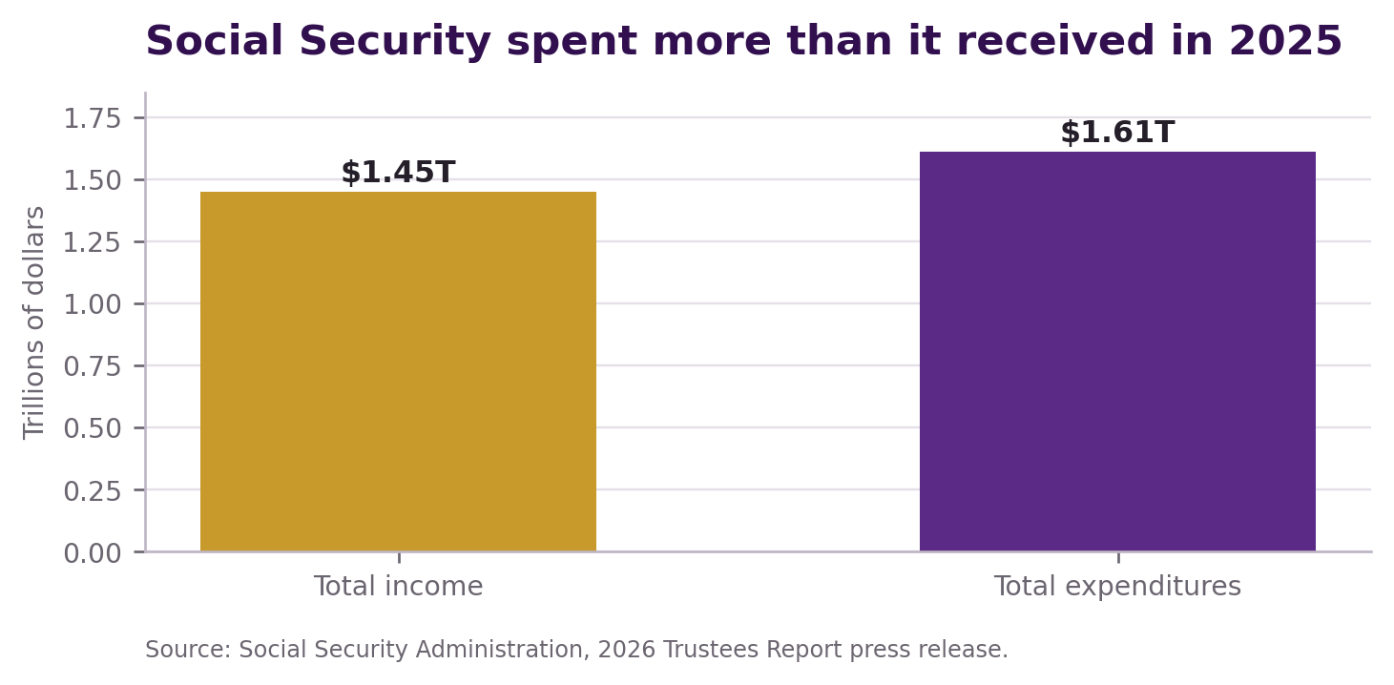
Figure 1. Social Security's 2025 outflow exceeded total income. Reserves covered the difference, but reserves are finite.
The 2026 Trustees project that the Old-Age and Survivors Insurance reserve will become depleted in the fourth quarter of 2032. Continuing income would then be sufficient to pay about 78 percent of scheduled OASI benefits. If the retirement and disability funds are considered together, combined reserves are projected to become depleted in 2034, with about 83 percent of scheduled benefits payable at that time.[3]
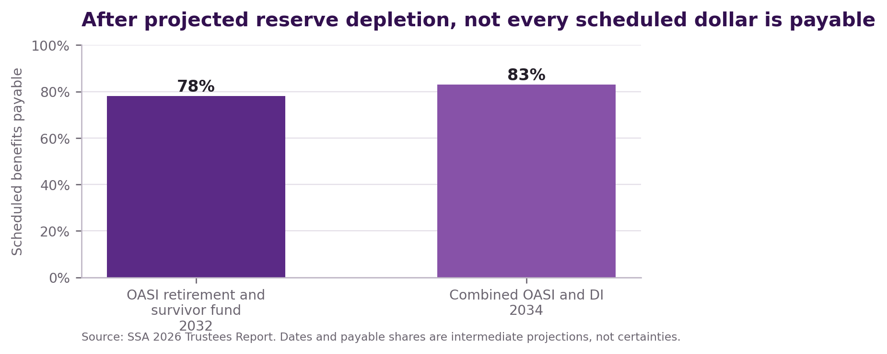
Figure 2. The current-law warning. Reserve depletion does not mean that every benefit becomes zero, but continuing income would not cover every scheduled dollar.
The projected 75-year combined actuarial deficit is 4.42 percent of taxable payroll. The words "actuarial deficit" mean that, under the Trustees' assumptions and across the valuation period, scheduled costs exceed dedicated financing plus starting reserves by that measured amount.[4]
This is not a claim that the program is bankrupt today. Benefits are being paid. Payroll-tax income continues. The Disability Insurance fund is projected to remain adequately financed over the long range under the intermediate assumptions. The central near-term problem is the retirement and survivor fund.
It is also incorrect to say that the trust funds are imaginary. They are accounts in the Treasury. Money not needed immediately is invested in special Treasury securities backed by the United States. Those securities earn interest and can be redeemed to pay benefits. But the trust funds cannot permanently spend more than dedicated income and reserves, and under current law they cannot simply borrow without limit.[5]
Three truths must therefore be held together:
- Social Security has real dedicated income and real legal obligations.
- The trust-fund reserves are real financial claims, not a warehouse of paper currency.
- The reserves are being drawn down and cannot cover a permanent financing gap.
The Purple Way does not solve this arithmetic by pretending it is only an accounting trick. It accepts the ledger and then expands the field of action.
CHAPTER 3

The Demographic Weight on Future Workers
Social Security is largely financed by current contributions on covered earnings. That makes the relationship between workers and beneficiaries important.
There were about 2.6 covered workers for each Social Security beneficiary in 2025. Under the Trustees' intermediate assumptions, that ratio declines to about 1.9 by 2075 and then remains near that level.[6]
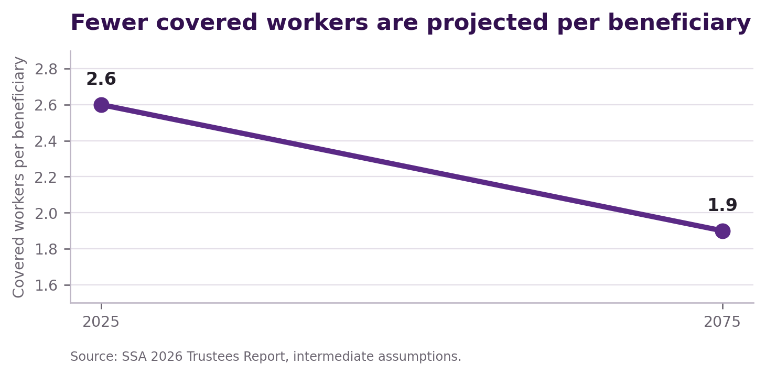
Figure 3. Fewer covered workers are projected to support each beneficiary over time. Productivity and real wages matter more when the ratio falls.
The decline is mainly demographic. Lower-birth-rate generations replace larger generations at working ages while the beneficiary population grows. People living longer is a human success, but longer retirement also increases the number of years that benefits may be paid.
No policy philosophy can repeal age structure. The Purple Way cannot promise to produce millions of additional workers by declaration. It can influence the strength of the workers the nation has.
It can help more people enter covered employment. It can recognize credentials more quickly. It can reduce preventable illness and injury. It can give caregivers paths back into paid work. It can help older workers move into mentoring and quality roles when heavy physical work is no longer safe. It can help disabled people work to their capacity without treating protection as a trap. It can convert unrecognized knowledge into portable earning power.
The number of workers matters. The amount of real covered wages each worker earns also matters.
Official sensitivity analysis illustrates the connection. Under the Trustees' three real-wage-growth assumptions, the 75-year actuarial deficit ranges from 5.61 percent of taxable payroll in the lower-growth case to 3.27 percent in the higher-growth case. Stronger real wages materially improve the system, but even the higher-growth case does not eliminate the deficit.[7]
That fact establishes a central rule for this book:
Human-capital growth is part of Social Security solvency, but it is not a substitute for an exact financing law.
The Purple Way must do both.
CHAPTER 4

A Benefit Is What It Can Buy
In January 2026, the estimated average benefit for a retired worker was $2,071 per month after the year's 2.8 percent cost-of-living adjustment.[8]
The number matters. The purchasing power matters more.
A $2,071 payment can feel larger when rent, property tax, electricity, food, medicine, insurance, and transportation are affordable. It can feel smaller after those bills rise, even when the payment receives a cost-of-living adjustment.
Households headed by a person age 65 or older spent an average of $61,432 in 2024 according to the Consumer Expenditure Survey. Housing averaged $22,193, transportation $9,538, food $7,940, and healthcare $7,799. These are population averages, not a required retirement budget, but they show where cost pressure lives.[9]
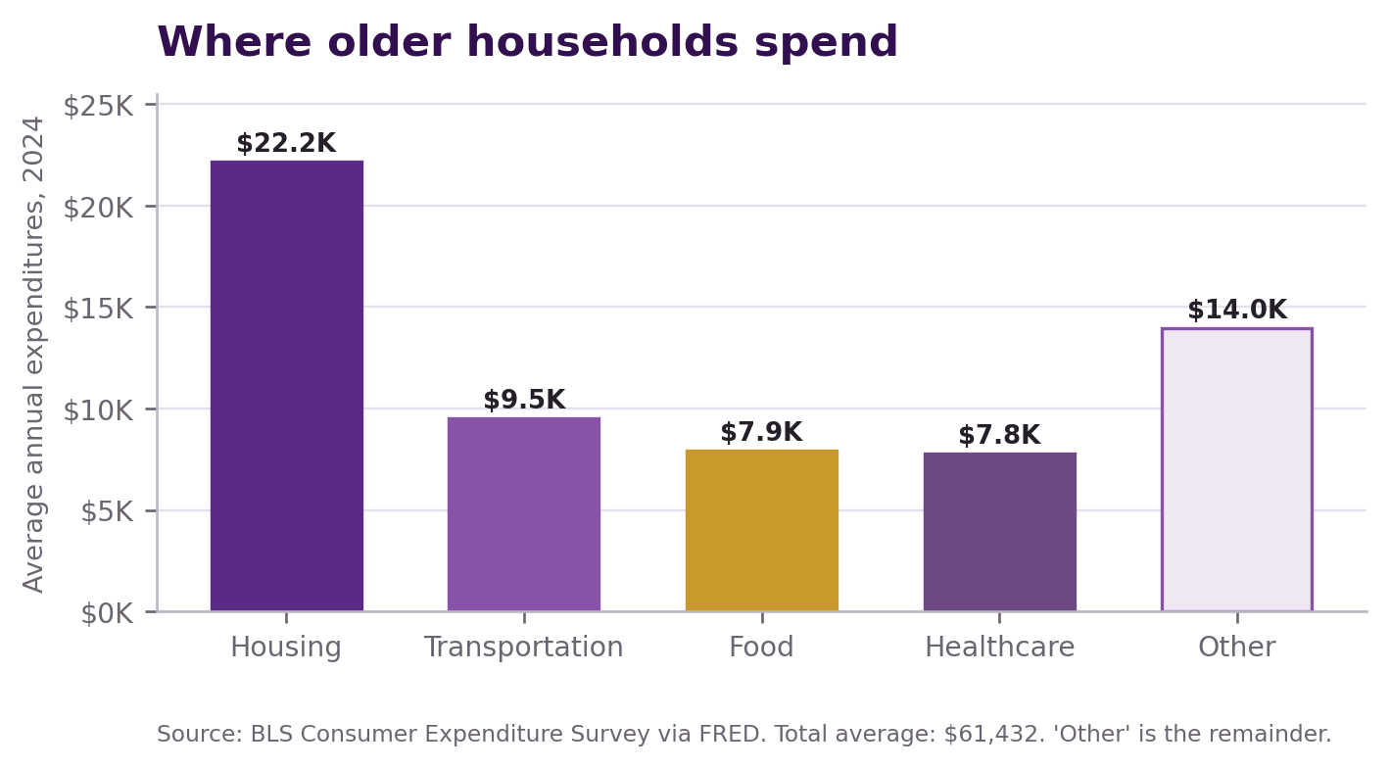
Figure 4. Housing, transportation, food, and healthcare dominate the average spending of households headed by someone age 65 or older.
The usual political response focuses on the income side. Raise the check. Change the COLA. Add a tax credit. Increase a subsidy. Each proposal can provide genuine help.
The Purple Way adds the cost side.
If a lawful public-benefit contract lowers a senior's electricity bill by $100 a month, the result resembles a $100 improvement in usable income even though Social Security did not spend another trust-fund dollar. If lower insurance losses reduce a premium by $80, safe transportation saves $60, and food-production contracts save $70, the household keeps another $310 each month.
That is not the same as increasing the federal benefit. A cost reduction may vary by place and household. It must be verified. It can disappear if a contract fails. The earned check remains essential.
But the real purpose of retirement income is not to create a large printed number. It is to secure shelter, food, health, mobility, dignity, and choice.
The Purple Way measures both.
CHAPTER 5

What the COLA Does - and Does Not Do
Social Security's cost-of-living adjustment is one of the program's greatest protections.
Under current law, the COLA is based on increases in the Consumer Price Index for Urban Wage Earners and Clerical Workers. The formula compares the third-quarter average with the relevant prior base. If there is no increase, or the rounded increase is zero, there is no COLA for that year.[10]
The COLA protects beneficiaries against measured inflation. It does not lower the original cost. It responds after prices have risen.
Suppose a retiree receives $2,000 and a measured basket rises 3 percent. A 3 percent COLA raises the check to about $2,060. The person has more dollars but approximately the same measured purchasing power before considering taxes, Medicare premiums, spending patterns, and timing.
Now suppose a Purple cost-reduction program lowers important prices while the nominal benefit remains $2,000. The retiree receives no larger number, but the same number buys more.
Under the current COLA design, negative inflation does not create a negative COLA. If the CPI does not rise above the applicable base, no COLA is paid. The next positive COLA waits until the third-quarter average exceeds the last qualifying base.[11]
This feature creates a potentially powerful Purple result. If essential prices fall and the scheduled nominal benefit is protected, real purchasing power rises.
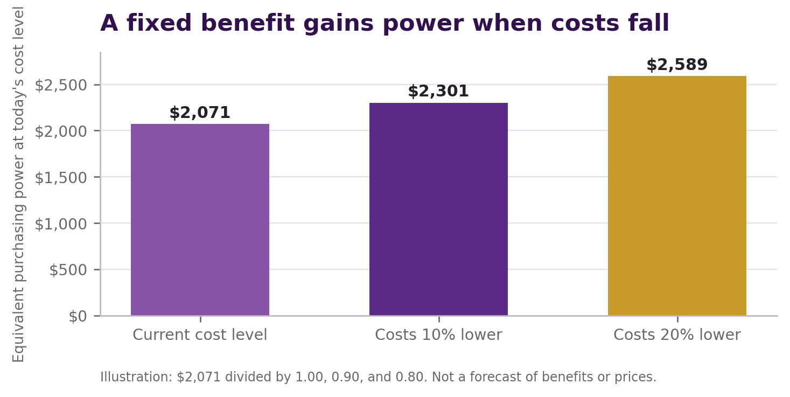
Figure 5. Illustration only: a fixed $2,071 benefit buys more when the relevant cost level falls. This is arithmetic, not a forecast.
There are important limits.
- A retiree's personal basket may rise even when the broad index does not.
- Healthcare and housing can behave differently from food or manufactured goods.
- Medicare premiums or tax withholding can change the net payment.
- Congress can change benefit law.
- A broad deflation caused by recession can damage jobs, pensions, assets, banks, and public finance.
The Purple objective is therefore not simply "zero COLAs." It is a lower need for large COLAs because real costs are being reduced without sacrificing output, wages, access, or safety.
CHAPTER 6

Why Future Generations Have Reason to Worry
A young worker can look at Social Security and see three risks.
The first is the financing risk. Current projections do not support every scheduled future dollar without legislative action.
The second is the purchasing-power risk. Even if benefits are paid, essential costs may absorb too much of the check.
The third is the independence risk. A worker may reach retirement with little savings, no pension, expensive housing, poor health, high debt, and no personally owned productive asset.
The common debate asks young people to choose a fear.
One side warns that taxes will rise to preserve promises. Another warns that benefits will be reduced to preserve the government's ledger. Some propose private accounts and market exposure. Others propose larger federal benefits. Most arguments remain centered on the transfer between worker and beneficiary.
The Purple Way asks whether the entire nation can become more capable.
Can the future worker produce more real value per hour? Can the worker keep more income because recurring costs are lower? Can the employer provide portable retirement capital? Can the community prevent avoidable health and transportation losses? Can federal financing be made exact before a crisis? Can a gradual reduction in debt dependence strengthen the dollar without causing mass unemployment?
If the answer is yes, the conflict between generations becomes less severe. Future workers are not merely asked to finance a promise created before they were born. They inherit productive systems, lower cost structures, personal capital, and a transparent public compact.
That is the deeper Purple transformation.
It does not promise each generation something for nothing. It gives each generation something productive to carry forward.
PART TWO

The Purple Economic Connection
Social Security cannot be separated from the economy that finances it or the prices that determine what its benefits can buy. The Purple Way connects those systems without pretending that one mechanism solves every problem.
CHAPTER 7

The Four Ledgers of Retirement Security
The Purple Way evaluates Social Security through four ledgers.
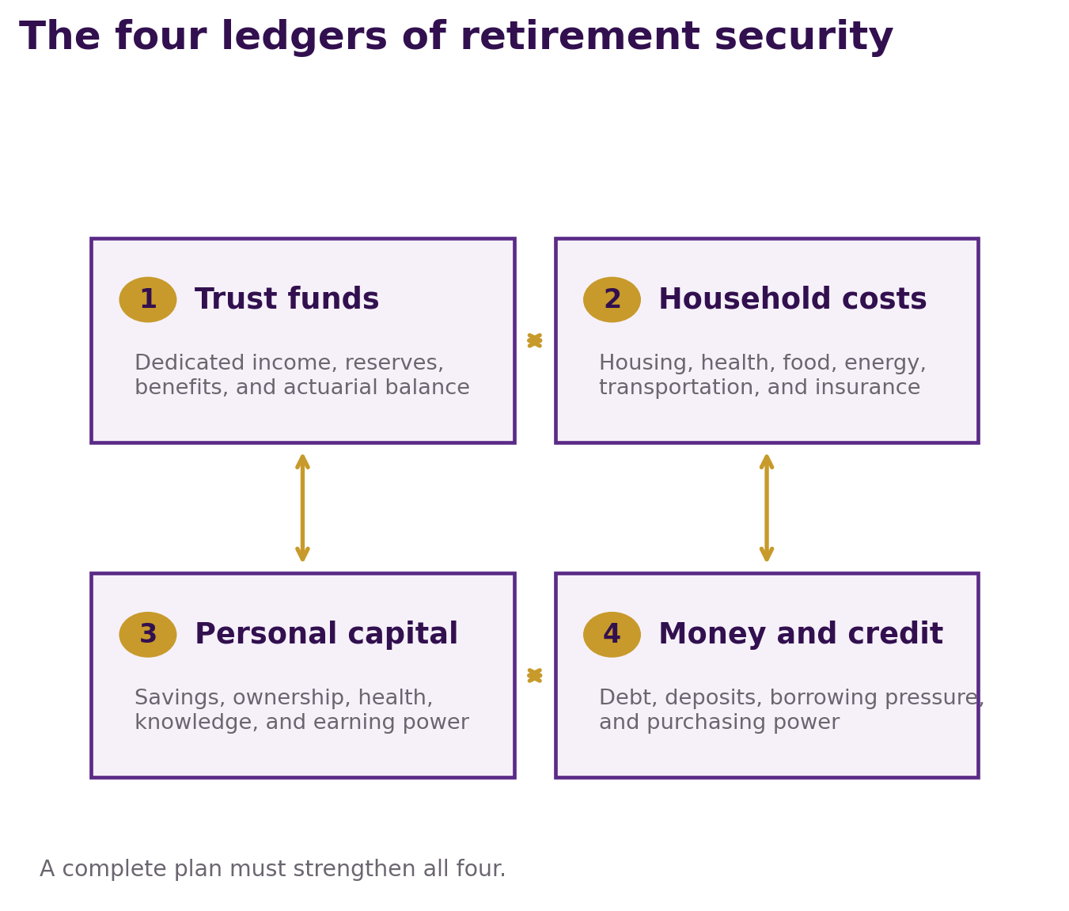
Figure 7. The four ledgers of retirement security. A complete plan must strengthen the trust funds, household costs, personal capital, and the money-and-credit system together.

Ledger One - The trust funds
This ledger records dedicated income, interest, reserves, scheduled benefits, and administrative costs. It is the legal financing core. It must balance over an independently defined period.

Ledger Two - The household cost of living
This ledger records what retirees actually pay for housing, utilities, food, healthcare, transportation, insurance, communication, and necessary services. It determines the real usefulness of the benefit.

Ledger Three - Personal capital
This ledger includes savings, home equity, retirement accounts, tools, knowledge, credentials, health, relationships, and the ability to earn or mentor. It determines how much choice surrounds the federal floor.

Ledger Four - National money and credit
This ledger includes public and private debt, bank deposits, interest burdens, borrowing pressure, fiscal rescue, and monetary accommodation. It influences the long-run value and stability of the dollar used to pay the benefit.
Traditional proposals often improve one ledger by stressing another.
A benefit increase can improve the household-income ledger but worsen the trust-fund ledger if it lacks dedicated financing. An abrupt benefit cut can improve the trust-fund ledger but damage the household ledger. Aggressive monetary contraction can strengthen purchasing power but damage employment, wages, banks, and tax revenue. A subsidy can lower today's bill but preserve the expensive system that produces tomorrow's bill.
The Purple Way requires every major proposal to publish its effect on all four ledgers.
That is more than accounting. It is a discipline against political illusion.
CHAPTER 8

Human Capital Is Social Security Capital
Human Capital Conservatism begins with a different definition of wealth.
Money is a claim on value. Human capital helps create the value being claimed.
Knowledge, skill, health, trust, relationships, tools, technology, infrastructure, and ownership are productive capital. They allow a person to solve problems, produce goods, deliver services, prevent loss, and train another person.
Social Security becomes stronger when that capital produces covered earnings.
A young adult who enters stable covered employment earlier contributes for more years. A worker whose credential is recognized earns closer to productive capacity. A parent who receives effective childcare and training can return to covered work. A technician who avoids a preventable injury can contribute longer. An older specialist who moves from heavy work into mentoring preserves earnings and transfers knowledge.
The Trustees' sensitivity analysis confirms the direction: higher real wage growth improves actuarial balance because payroll revenue rises immediately while higher future benefit levels emerge more gradually.[7]
But the Purple Way must avoid a mistake. "Build human capital" is not a financing formula. A hopeful future worker cannot be entered into today's trust-fund account as cash.
Human capital must be measured through outcomes:
- Covered employment obtained and retained.
- Real wages earned.
- Credentials completed and used.
- Disability or injury prevented without denying valid claims.
- Years of productive participation added voluntarily and safely.
- Personal savings and ownership accumulated.
- Recurring household costs reduced.
This is why the phrase "the nation is a bank with feet" matters. Citizens carry capital through the economy. But a nation that understands this still needs an honest financial bank account.
The Purple Way honors both kinds of capital.
CHAPTER 9

The Public Benefit Exchange
The Public Benefit Exchange is the operating system of the Purple Way.
A government sometimes has something valuable that a private or nonprofit participant wants: temporary tax treatment, expedited lawful permitting, procurement opportunity, access to public land or facilities, research support, recognition, regulatory coordination, or another benefit authorized by law.
The public also needs measurable value: lower energy bills, safer transportation, lower insurance losses, useful credentials, affordable fresh food, efficient housing, or stronger infrastructure.
The Public Benefit Exchange joins the two.
The public benefit is not given away because a company promises jobs or public goodwill. It is earned after defined performance is verified.
For Social Security, eligible public value could include:
- New covered jobs with published wage progression.
- Employer-funded Personal Independence Accounts.
- Late-career transition and mentoring roles.
- Lower recurring costs for qualifying retirees and disabled people.
- Accessible housing or transportation infrastructure.
- Verified health and safety improvements that preserve work capacity.
- Cash contributions to the trust funds where lawfully authorized and actuarially counted.
The exchange must remain voluntary, competitive, transparent, and reviewable. It cannot authorize secret favoritism, price fixing, discrimination, forced labor, benefit denial, or indefinite tax privilege.
The Purple Way is not anti-profit. It seeks a better bargain.
A company may become wealthier by solving a public cost problem. The public becomes wealthier because the solution leaves people with more purchasing power and the nation with more productive capacity.
CHAPTER 10

The Statesman Contract
The Statesman Contract is the enforceable agreement inside a Public Benefit Exchange.
It answers questions ordinary political promises often avoid:
- What exact public benefit is being offered?
- What legal authority permits it?
- What exact public value must be delivered?
- Who qualifies and who is protected?
- What is the baseline before the contract begins?
- How is performance measured?
- Who verifies the result independently?
- When is the benefit earned?
- What happens if performance fails?
- When does the contract end?
A Social Security-related Statesman Contract could involve a manufacturer, utility, insurer, health system, housing builder, technology company, training provider, or investment partnership.
Suppose an employer seeks a public tax advantage. The contract might require 2,000 new covered jobs, specified starting wages, portable credentials, employer retirement contributions, disability-safe job design, and published retention rates. The public benefit is released in stages only after those outcomes occur.
Suppose a utility seeks access to a long-term public infrastructure opportunity. The contract might require verified electricity credits for qualifying senior households, grid reliability, transparent cost allocation, and no reduction in service quality. Those household savings remain outside the Social Security trust funds but strengthen the real value of benefits.
Every contract needs audits, clawbacks, privacy rules, due process, competition, and a sunset. No participant should own the public policy permanently.
The title "statesman" describes conduct, not social rank. The participant earns advantage by creating measurable value that outlasts the advantage.
CHAPTER 11

Lower Recurring Costs Before Monetary Contraction
The Purple Way does not begin by deleting dollars.
It begins by deleting avoidable costs.
A household borrows when income cannot cover food, utilities, repairs, medical bills, insurance, or transportation. A business borrows when energy, inventory, equipment, payroll, tax, or insurance costs outrun cash flow. A government borrows when continuing obligations exceed recurring revenue.
Those pressures support continuing demand for new credit and money-like claims.
The Purple sequence is:
- Build productive capacity.
- Remove a verified recurring cost.
- Preserve useful output, wages, and access.
- Improve household, business, and government cash flow.
- Use part of the improvement to repay old principal and build savings.
- Reduce the need for replacement borrowing.
- Permit money growth to slow or turn modestly negative only if the productive economy remains stable.
This order is essential for Social Security.
Payroll contributions depend on covered wages. A recessionary contraction that destroys jobs can weaken trust-fund income. Falling asset prices can damage retirement accounts. Deflation can increase the real burden of fixed debt. Bank losses can restrict useful credit.
The Purple Way therefore seeks productive contraction, not destructive deflation.
The objective is for real costs to fall while useful production and covered payroll remain strong. A refrigerator should cost less to operate because it uses less energy, not because its owner lost a job. Housing should become more affordable because construction and financing systems improved, not because neighborhoods collapsed.
Productivity leads. Monetary contraction follows.
CHAPTER 12

How Productive Monetary Contraction Works
Most money used in the modern economy is not paper currency. It is held in bank deposits and related liquid accounts.
When a commercial bank makes a loan, it normally creates a loan asset and a matching deposit liability. When principal is repaid, deposit money can be destroyed. Loans and repayment are therefore important ways that money expands and contracts.[12]
The Purple Way would influence this process indirectly.
If a household saves $300 each month because electricity, food, insurance, and transportation costs fall, it has choices. It can consume more, save, invest, or repay debt. If many households use part of the saving to reduce credit-card, auto, mortgage, or other principal - and do not replace the old debt with equal new borrowing - deposit growth can slow.
If companies lower operating costs, they can repay lines of credit while maintaining production. If governments face fewer emergency rescues and preserve the savings, Treasury borrowing can be lower than it otherwise would have been.
None of this guarantees that a measured money aggregate will shrink. Banks may make new productive loans. People may spend savings. The Federal Reserve may change policy. Global demand for dollar assets may change. Money velocity may rise or fall.
The Purple influence is therefore a change in pressure, not a command.
The plan makes continuing monetary expansion less necessary by making the real economy less dependent on fresh credit to preserve ordinary life.
For Social Security, the desired outcome is not a spectacular one-year contraction. It is a long period in which productive output and covered wages grow faster than the number of new monetary claims, allowing each benefit dollar to retain or gain real usefulness.
CHAPTER 13

What a Stronger Dollar Means for a Retiree
The phrase "stronger dollar" can mean two different things.
In foreign-exchange markets, it means the dollar buys more of another currency. That can lower some import costs but also affect exporters, tourism, capital flows, and foreign debt.
In this book, the main meaning is domestic purchasing power: a dollar buys more useful goods and services at home.
For a Social Security recipient, domestic purchasing power is the more direct test.
An illustrative calculation shows the scale. If a $2,071 monthly benefit faces a cost level 10 percent lower, it has the same purchasing power as about $2,301 at the original cost level. At a cost level 20 percent lower, it has purchasing power equivalent to about $2,589 at the original level. These are mathematical equivalents, not predictions.[8]
The gain is especially important for people with fixed or slowly changing income. Cash savings also gain real value when prices fall safely.
But a stronger dollar creates winners and risks.
- A borrower with fixed debt owes more in real terms if income falls.
- A bank may face higher defaults.
- A business may see nominal revenue decline faster than costs.
- An exporter may become less competitive if foreign exchange moves sharply.
- A pension or retirement portfolio may lose market value during disorderly contraction.
The Purple Way must therefore strengthen balance sheets before it welcomes monetary contraction. Debts should be refinanced where lawful and prudent. Productive profit should be protected. Banks should be stress-tested. Vulnerable households should not be sacrificed to a monetary target.
The dollar becomes stronger because society created more value and needed fewer new claims, not because policy makers made people desperate for scarce cash.
CHAPTER 14

Why Prices Must Fall Safely
Lower prices sound universally good. The economic reality is more demanding.
There are at least three kinds of falling prices.
Productivity-led price reduction occurs when better technology, logistics, energy efficiency, competition, skill, or scale lowers the real cost of production. Output can rise while price falls. This is the Purple target.
Temporary market adjustment occurs when supply and demand shift. It can be healthy or disruptive depending on the product and speed.
Debt-deflation occurs when collapsing demand, falling income, defaults, and forced selling push prices down while fixed obligations remain. This can destroy employment, banks, pensions, and tax revenue.
Social Security adds a special financing constraint. Payroll-tax revenue is collected from nominal covered earnings. If a broad deflation cuts nominal wages and employment, trust-fund income can fall. At the same time, current law does not apply a negative COLA to reduce existing benefit amounts. The purchasing power of the benefit may rise while the cash financing gap widens.
That is why the Purple sequence should initially seek lower essential costs relative to covered wages, not a forced decline in every price and wage.
The national dashboard should pause monetary contraction if:
- Covered employment falls materially.
- Nominal covered payroll weakens faster than scheduled costs.
- Defaults or bank losses rise beyond safety thresholds.
- Essential supply declines.
- Retiree access to healthcare, housing, food, energy, or transportation worsens.
- Trust-fund actuarial balance deteriorates outside the enacted correction path.
The Purple Way does not worship a lower price index. It serves a more secure human life.
PART THREE

Transforming Social Security
The Purple Way would not replace earned social insurance with charity, private speculation, or a collection of corporate favors. It would protect the federal floor, repair its financing, and build new layers of security around it.
CHAPTER 15

Preserve the Earned Floor
The first rule of Purple Social Security reform is preservation.
Retirement, survivor, disability, and family benefits are not bargaining chips to be exchanged for promises of future growth. Current beneficiaries organized their lives under existing law. Near-retirees have limited time to change work, saving, or claiming plans. Disabled people and surviving families cannot be told to become productive enough to replace an insured benefit.
The Purple earned-floor guarantee would contain five protections.

1. No abrupt reduction for current beneficiaries
Scheduled benefits should not be cut suddenly to make the ledger appear balanced. If legislation changes future formulas, current beneficiaries and people close to retirement need explicit protection.

2. Survivor and disability insurance remain central
Social Security is not merely an old-age annuity. Any reform that ignores death and disability misunderstands the program.

3. The contributory structure remains visible
Workers should be able to see covered earnings, contributions, estimated benefits, and the status of the trust funds. The earned character of the program encourages legitimacy across generations.

4. Purple assets remain outside the trust funds
Personal Independence Accounts, employer accounts, home equity, or Public Benefit Exchange credits supplement Social Security. They do not give government permission to reduce an earned benefit dollar for dollar.

5. Protection does not mean financial denial
A promise cannot be preserved by refusing to measure its cost. The earned floor must be supported by sufficient dedicated financing.
This position differs from both extremes.
It rejects the claim that Social Security is merely dependency to be privatized or abandoned. It also rejects the claim that declaring benefits untouchable is a complete financing plan.
The Purple Way protects the person and the ledger.
CHAPTER 16

Build the Purple Solvency Firewall
The Purple Solvency Firewall is the legal boundary between hopeful economic gains and spendable Social Security money.
Its rule is simple:
No projected Purple saving, productivity gain, cost reduction, or corporate promise may be counted as trust-fund financing until the value becomes legally dedicated cash and is recognized in an official actuarial score.
The firewall would require legislation to meet six tests.

Test One - A 75-year actuarial score
The Social Security Administration's Office of the Chief Actuary should publish the effect of every financing and benefit provision under common assumptions.

Test Two - Sustainable solvency beyond the average
A package should not merely produce a 75-year average balance while leaving a large deficit in the final year. Policymakers must disclose the 75th-year balance and reserve path.

Test Three - Dedicated revenue
Money used to finance Social Security must be legally dedicated. General economic growth, lower federal spending elsewhere, or reduced inflation cannot be booked as trust-fund income.

Test Four - No speculative offset
Unbuilt infrastructure, unverified contracts, future fraud reduction, and estimated behavior changes cannot replace cash financing.

Test Five - Automatic warning and correction
If annual actuarial updates move the program outside a defined safe corridor, Congress must consider a published menu of corrections. The process should begin years before reserve depletion, not during a payment crisis.

Test Six - Intergenerational transparency
Every change should show its effect on current beneficiaries, near-retirees, young workers, low earners, caregivers, disabled workers, survivors, and people in physically demanding jobs.
The firewall does not dictate one political mix of revenue and benefits. It dictates honesty.
A final Purple bill could choose among gradually broadened dedicated contributions, changes to the taxable base, additional dedicated receipts, carefully designed future formula adjustments, or a combination. The exact package must be public and scored. This book does not invent a number and call it official.
That is the difference between a philosophy and a law capable of paying benefits.
CHAPTER 17

Human-Capital Contribution Engines
Social Security receives more recurring income when covered payroll rises.
A Human-Capital Contribution Engine is a Statesman Contract designed to create verified covered employment and wages while building worker capacity.
Consider a company seeking a significant public benefit. Under a Purple contract, the company might be required to deliver:
- A defined number of new covered positions.
- Published starting wages and wage progression.
- Portable credentials paid by the employer.
- Health and safety systems that preserve working capacity.
- Childcare, transportation, or scheduling support where those barriers block participation.
- Employer-funded Personal Independence Accounts.
- Late-career transition roles.
- A defined cash contribution to the trust funds if authorized and included in the actuarial score.
The company does not earn the entire public advantage on the day it announces the project. It earns the advantage as employees are hired, trained, retained, and paid.
This design improves Social Security in three ways.
First, covered payroll generates dedicated contributions under current law.
Second, stable employment reduces the number of zero or low-earning years in a worker's benefit record.
Third, higher real wages can improve long-range actuarial balance, even though official evidence shows they cannot close the full gap by themselves.[7]
The contract must distinguish a new result from a relabeled old one. A company cannot receive a public benefit for jobs it would have created anyway without a measurable additional public return. It cannot replace existing workers with nominally new workers to collect credit. It cannot convert employees into misclassified contractors to reduce covered payroll.
The Human-Capital Contribution Engine is not a hidden payroll tax. It is a voluntary exchange: public advantage for verified public value.
CHAPTER 18

Personal Independence Accounts
Social Security should remain the earned floor. A worker should also own something above the floor.
The Purple Way proposes a portable Personal Independence Account for each participating worker. The account would be legally separate from the Social Security trust funds and owned for the worker's benefit.
Contributions could come from:
- Employers participating in Statesman Contracts.
- The worker's voluntary savings.
- Matching funds earned through verified education or employment milestones.
- Public Benefit Exchange consideration lawfully structured for retirement capital.
- Philanthropic or community contributions.
- A share of verified company savings created by the worker's productivity.
The account should not be financed by diverting current Social Security payroll contributions unless a complete actuarial score proves that the trust funds remain solvent. Taking money from the earned floor to create a new account would simply move insecurity from one ledger to another.
The account should be:
- Portable between employers and states.
- Low-cost and professionally governed.
- Diversified by default.
- Protected from predatory fees and sales pressure.
- Accompanied by plain-language education.
- Subject to strong spousal, beneficiary, and disability rules.
- Difficult to drain for ordinary consumption while allowing carefully defined emergencies.
- Protected by appeal and fiduciary standards.
Personal capital changes retirement psychology.
A person with Social Security, an independence account, useful knowledge, manageable housing cost, and low debt approaches retirement with choices. The person may work, mentor, volunteer, care for family, start a small enterprise, or rest.
The federal check is no longer the whole structure. It is the dependable foundation.
CHAPTER 19

Retirement Cost-Reduction Credits
The Purple Way can strengthen a retiree without increasing trust-fund spending.
A Retirement Cost-Reduction Credit is a verified reduction in a necessary bill delivered through a Public Benefit Exchange. It is not a Social Security benefit and should not be financed from the OASI or DI trust funds.
Examples could include:
- Electricity credits from an energy Statesman Contract.
- Lower insurance premiums tied to independently verified loss reduction.
- Transportation credits for medical and essential travel.
- Fresh-food credits supported by lower-cost production and logistics.
- Home-safety upgrades that reduce falls, fire, weather, and insurance loss.
- Broadband or communication credits that improve access to telehealth and benefit services.
The distinction between a subsidy and a productive credit is important.
A subsidy may pay part of an expensive bill while leaving the expensive system unchanged. A Purple credit should be financed by new productive value, verified savings, or a defined private exchange. The source must be transparent.
The credit also needs protections.
- It must not reduce an earned Social Security benefit.
- Its tax treatment must be clear.
- Access must not depend on political loyalty or surrender of privacy.
- The provider must not raise the underlying price to capture the credit.
- The benefit must be portable or replaceable if a provider exits.
- It must end if the promised public value is not delivered.
The purpose is not to surround every retiree with bureaucratic coupons. The purpose is to attack recurring costs at their source.
The best credit eventually makes itself unnecessary because the underlying market price becomes sustainably lower.
CHAPTER 20

Caregivers, Disability, Survivors, and Family Protection
A retirement-only plan is not a complete Social Security plan.

Caregivers
People can lose covered earnings while caring for a child, disabled relative, or aging parent. The Purple Way should recognize verified caregiving without creating a system that traps caregivers outside paid work permanently.
Possible tools include temporary caregiver credits in the benefit formula, portable training, respite support, flexible covered employment, and reentry services. Any new credit must be actuarially scored and financed.

Disabled workers
Disability insurance protects people whose conditions stop or limit work. Human-capital policy can add early accommodation, rehabilitation, accessible technology, and voluntary work supports. It must never presume that every disabled person can work enough to replace insurance.
No automated system should deny disability benefits based on an opaque score. Medical evidence, due process, human review, representation, and appeal must remain available.

Survivors
A worker's death can remove income, care, knowledge, and emotional stability at once. Survivor benefits provide a cash floor. The Purple Way would add family continuity: benefit navigation, grief support, housing stability, education accounts, debt review, and safeguards against financial exploitation.

Families
When children receive family or survivor benefits, the nation should help protect the benefit and the child's future capital. Age-appropriate financial education, tutoring, mentoring, and protected education assets can turn emergency protection into a bridge toward adulthood.
Purple kindness is not a demand that vulnerable people prove economic usefulness before receiving help.
It is the will to protect the person today and, wherever possible, build greater capability for tomorrow.
CHAPTER 21

The Older Worker as a National Asset
Retirement policy often treats work as a switch. A person is either fully employed or fully retired.
Real life is more varied.
A sixty-four-year-old technician may no longer be able to lift, climb, or work in extreme heat, yet may know more about diagnosis, safety, quality, and repair than younger workers. A nurse may leave heavy bedside work but remain an excellent trainer. A farmer may transfer decades of soil, animal, and weather knowledge. A business owner may teach contracting and cash flow.
The Purple Way would create late-career paths built around knowledge rather than physical punishment.
Statesman Contracts could reward employers for:
- Redesigning roles around mentoring, quality, safety, and troubleshooting.
- Offering part-time covered work with predictable scheduling.
- Adapting tools and workplaces.
- Providing phased retirement without age discrimination.
- Documenting and transferring critical knowledge.
- Supporting informed Social Security claiming decisions.
This is not a disguised increase in the retirement age.
A higher national retirement age can look reasonable for a desk worker and cruel for a person whose body has absorbed forty years of heavy labor. The Purple Way rejects one physical assumption for every occupation.
People should work longer only when they choose and can do so safely. Disability protection, early retirement rules, and physically demanding-work safeguards remain necessary.
When an older person wants to contribute, the nation should not waste the capital. When the body needs rest, the nation should honor the earned protection.
CHAPTER 22

Knowledge Navigation Without Digital Control
Social Security rules can be difficult. Claiming age, spousal coordination, survivor benefits, disability, earnings tests, Medicare, taxes, and work history can interact.
Many people make permanent decisions while grieving, ill, frightened, or unfamiliar with the system.
The Purple Way supports a combined AI-and-human retirement navigator.
The navigator could:
- Explain a Social Security Statement in plain language.
- Compare claiming ages without making the decision for the person.
- Identify missing or incorrect earnings records.
- Explain survivor and disability possibilities.
- Coordinate questions about Medicare and taxes.
- Build a household cash-flow plan.
- Show how lower-cost Purple programs affect the budget.
- Connect people to a trained human counselor or representative.
The tool must serve the individual, not control the individual.
It should never:
- Deny or reduce a benefit through an unexplained algorithm.
- Sell financial products because of hidden compensation.
- Share health or financial data without lawful consent.
- manipulate a person into delaying a claim that is needed.
- assume that a statistically typical life expectancy applies to an individual.
- eliminate human review, notice, or appeal.
Knowledge is capital only when the person can understand and use it.
The Purple Way socializes knowledge, not surveillance.
PART FOUR

Lowering the Retiree's Real Cost of Living
The most direct way to increase the real power of a benefit is to lower the necessary bills competing for it. The following chapters show how Purple contracts could work on the largest recurring costs without spending Social Security trust-fund money.
CHAPTER 23

Housing and Home Stability
Housing was the largest average expenditure for households headed by someone age 65 or older in 2024: $22,193.[9]
The number includes different situations. Some people rent. Some own without a mortgage. Others still have mortgage debt. Property taxes, insurance, utilities, repairs, maintenance, accessibility, and storm risk can remain expensive even when the loan is paid.
The Purple housing strategy would attack recurring cost and risk.
Statesman Contracts could support:
- Durable, energy-efficient home components.
- Standardized construction systems that reduce labor and material waste.
- Roof, wind, fire, flood, and weather improvements tied to verified insurance savings.
- Home-safety modifications that prevent falls and support aging in place.
- Lower-cost repair networks with published prices and quality guarantees.
- Property-tax relief carefully targeted and transparently financed.
- Accessible smaller homes near services without forced displacement.
- Shared-equity or community arrangements that preserve resident rights.
A contract must measure the entire housing bill. A builder should not claim success because the sale price is lower if insurance, utilities, maintenance, fees, or financing become higher.
The Purple metric is total recurring housing cost at safe quality.
Housing policy also affects monetary contraction. A household with a manageable payment and low maintenance is less likely to rely on revolving debt. A safer home produces fewer insurance claims. Efficient housing uses less energy. Better cash flow can support saving and principal repayment.
The home becomes productive retirement infrastructure rather than a continuing financial emergency.
CHAPTER 24

Health, Fresh Food, and Preventive Capacity
Healthcare averaged $7,799 for households headed by someone age 65 or older in 2024. Medical expenses also pushed an estimated 7.5 million people into Supplemental Poverty Measure poverty in 2024.[2][9]
The Purple Way supports health coverage and goes beyond the insurance card.
Health begins with the systems surrounding the person:
- Affordable fresh food.
- Safe housing and clean air.
- Reliable transportation to care.
- Movement, prevention, and early detection.
- Medication access and adherence.
- Social connection and mental well-being.
- Clear health information.
A Purple health Statesman Contract could exchange a lawful public benefit for verified reductions in avoidable hospital use, medication errors, uncontrolled chronic disease, food insecurity, or transportation barriers.
The participant would not be paid merely for serving more expensive episodes. Part of the reward would depend on safer outcomes and lower total recurring cost, adjusted so providers are not punished for serving people with complex needs.
Fresh-food contracts could connect growers, processors, grocers, health systems, and transportation providers. Organic or minimally processed food can become more available when soil inputs, energy, refrigeration, packaging, spoilage, and logistics are reduced. The purpose is not to shame people for what they eat. It is to make the healthier choice affordable and practical.
Prevention must never become a reason to deny necessary care. A person with illness deserves treatment whether or not earlier prevention was possible.
Purple health policy expresses kindness through support with the will to transform conditions over time.
CHAPTER 25

Energy and Utility Independence
Electricity, fuel, water, communication, and temperature control are not optional for many older or disabled people.
The Purple Way would invite energy producers, utilities, manufacturers, investors, cities, and technology firms into carefully designed exchanges.
A participant might receive long-term access, tax treatment, siting coordination, or another lawful benefit in exchange for verified public value such as:
- Electricity credits for qualifying residents.
- New generation or storage capacity.
- Grid reliability and weather resilience.
- Efficient appliances and home retrofits.
- Waste-heat recovery and industrial cogeneration.
- Lower line loss and better local distribution.
- Transparent pricing and consumer protection.
Rustin Penland's refinery-and-electricity concept fits this structure. A large industrial participant could become more profitable through a tailored exchange while helping generate electricity value for communities. The company becomes wealthier by helping ordinary people keep more of their income.
The contract cannot promise "free electricity" without showing who pays, what is built, how reliability is protected, and whether costs are shifted to nonparticipants. The credit must come from measurable new value or a disclosed exchange.
For a retiree, a reliable $100 monthly utility reduction is concrete. It preserves food, medicine, savings, and peace of mind. For the national monetary system, lower recurring energy cost can reduce borrowing and price pressure across thousands of other goods.
Energy becomes a direct bridge between productive capital and stronger retirement purchasing power.
CHAPTER 26

Transportation and Insurance
Transportation averaged $9,538 for households headed by someone age 65 or older in 2024.[9]
Driving can also become more difficult with age, vision change, disability, medication, or reduced reaction time. Losing a license or vehicle can mean losing access to food, healthcare, family, worship, and community.
The Purple Way would treat safe mobility as retirement infrastructure.
Possible Statesman Contracts include:
- Demand-responsive community transportation.
- Medical transportation with reliable scheduling.
- Safer vehicles and driver-assistance systems with clear human control.
- Highway systems that reduce crashes through verified technology.
- Reduced insurance premiums tied to measured loss reduction.
- Lower-cost maintenance, tires, batteries, and repairs.
- Accessible walking and local service design.
An automaker or technology provider might earn a public benefit by delivering a verified reduction in severe crashes on qualifying roads. An insurer could agree in advance to pass a defined portion of verified claim savings to customers through lower premiums.
This structure requires strong safeguards. Automated driving cannot be mandated on unsafe terms. Consumers need notice, choice, cybersecurity, liability rules, and a manual alternative. Insurers cannot use opaque data to discriminate unlawfully or deny coverage.
The Purple goal is not technology for its own sake.
It is fewer injuries, fewer claims, lower premiums, reliable mobility, and more of the Social Security check left in the household.
CHAPTER 27

Food, Milk, and the Everyday Test
Food averaged $7,940 for households headed by someone age 65 or older in 2024.[9]
Food is also where monetary theory becomes visible. A person may never study M2, bank balance sheets, or actuarial payroll rates. Everyone understands the price of milk, eggs, vegetables, bread, and meat.
The Purple milk plan does not demand that the farmer become poorer so the shopper can pay less.
It lowers costs throughout the gallon:
- Feed and forage.
- Farm energy and water.
- Veterinary care and herd health.
- Equipment, maintenance, and financing.
- Processing and sanitation.
- Packaging and refrigeration.
- Transportation and spoilage.
- Retail energy, labor, and inventory loss.
Each participant can enter a complementary Statesman Contract. Each receives a public benefit only after independently verified savings or productive value. The contracts protect quality, supply, wages, farm viability, and competition.
When the total real cost falls, the retail price can fall without forcing a loss onto the farmer. The shopper gains purchasing power. The producer retains healthy productive profit. Less working-capital borrowing may be needed across the chain.
Milk is the everyday test for Social Security because a stronger benefit should be visible at the grocery register.
The same check should buy more fresh food, not merely contain more dollars after every price has already risen.
CHAPTER 28

Debt, Savings, and Fixed-Dollar Security
Retirees can be both savers and debtors.
A stronger dollar helps cash savings and fixed nominal benefits buy more. It can also increase the real burden of a mortgage, credit-card balance, auto loan, medical debt, or business obligation.
The Purple transition must address both sides.
Before broad monetary contraction, households should have access to lawful refinancing, fixed-rate conversion where prudent, transparent counseling, and principal-reduction strategies. Predatory fees should not consume the improvement.
Lower recurring costs should be divided deliberately:
- Protect basic consumption.
- Build an emergency reserve.
- Repay expensive principal.
- Fund the Personal Independence Account.
- Maintain the home, vehicle, health, and other productive assets.
This sequence prevents a common failure. A household saves $200 on one bill but immediately absorbs $200 of new discretionary debt. The cost reduction occurred, but independence did not improve.
Banks also need a transition plan. Productive monetary contraction should reduce deposits and loans gradually as customers repay. Banks need earnings from useful payment, custody, advisory, and productive-lending services rather than perpetual expansion of survival debt. Regulators should monitor liquidity, capital, concentration, and vulnerable institutions.
Social Security benefits must remain liquid and dependable throughout the process. The retiree should never become the shock absorber for a banking experiment.
The Purple Way strengthens fixed-dollar security by reducing debt before asking every dollar to carry more value.
PART FIVE

A Compact Between Generations
Social Security is not a gift from one age group to another. It is a continuing national compact. The Purple Way asks each generation to protect the earned floor and pass forward greater productive capacity than it received.
CHAPTER 29

From Child to Contributor
Future Social Security solvency begins long before a worker's first payroll contribution.
A child who can read, calculate, reason, communicate, use technology, understand health, and recognize a lawful contract enters adulthood with productive capital. A child whose education fails to create usable knowledge may enter low-paid, unstable, or uncovered work.
The Purple Way would connect education to national retirement security without turning children into financial instruments.
Every student should leave high school with:
- A recognized academic or occupational credential.
- Demonstrated financial and contract literacy.
- Understanding of Social Security, taxes, savings, insurance, and compound growth.
- A portable record of verified skills.
- Access to apprenticeships, higher education, entrepreneurship, or public service.
- A protected beginning asset or education account where financially possible.
- The ability to update skills throughout life.
Statesman Contracts could invite employers, colleges, unions, manufacturers, investors, and technology providers to finance or deliver this capacity. Public benefits would be tied to completion, employment, wage progression, and long-term usefulness - not enrollment alone.
Knowledge banking differs from fiat banking.
Fiat banking can place dollars in an account. Knowledge banking places productive capacity in the person. Money can be spent once. Knowledge can create value repeatedly, travel with the individual, and be taught to another generation.
The Purple Way does not choose between the two. A young person needs financial access and useful knowledge. But the human is the deeper capital.
When graduates become productive covered workers, Social Security gains contributors. When they also build personal assets, they enter retirement with more than a federal claim.
CHAPTER 30

A Stronger Covered Workforce
The long-range worker-to-beneficiary ratio is projected to decline. The Purple Way must therefore improve participation, productivity, and covered wages without exploiting workers.[6]
The workforce strategy has seven parts.

1. Earlier productive entry
Education should connect young adults to paid covered work without years of unnecessary delay or debt.

2. Rapid recognition of existing skill
Veterans, lawful immigrants, caregivers returning to work, and experienced workers often possess knowledge that is not translated into a credential. Assessment and bridge training can prevent wasted years.

3. Health and injury prevention
Safer work, preventive care, fresh food, and early treatment can preserve capacity. These supports must never become excuses to deny disability insurance.

4. Childcare and caregiving support
Flexible services can help people remain in covered employment while honoring family responsibility.

5. Technology that raises the worker
Automation should increase human capability and wage potential, not merely remove labor cost. Statesman Contracts can require training, ownership, or gain sharing when public benefits support automation.

6. Covered entrepreneurship
Small-business owners and self-employed workers need simple compliance, accurate contribution records, retirement accounts, and protection against misclassification.

7. Late-career knowledge roles
Mentoring and quality roles allow voluntary work to continue without demanding unsafe physical performance.
The outcome should be measured in real covered payroll, not employment slogans.
A million low-wage, unstable jobs may produce less human security than fewer high-productivity careers with wage progression. The system needs both sufficient workers and sufficient real wages.
The Purple Way grows the contribution base by growing the contributor.
CHAPTER 31

What the Purple Difference Looks Like at the Kitchen Table
Consider two retired households receiving the same $2,071 monthly Social Security benefit. The amount is illustrative and uses the 2026 estimated average retired-worker benefit.[8]

Household A - The old cost structure
The household faces rising electricity, insurance, food, transportation, medication, and home-repair bills. It uses a credit card for irregular expenses. Each COLA helps, but prices have already moved higher. The nominal check rises while financial calm does not.

Household B - The Purple cost structure
The household receives the same earned Social Security benefit. It also lives inside a community where productive contracts have reduced recurring costs.
An illustrative monthly ledger might look like this:
Purple result | Monthly improvement | Source of value
Utility reduction | $100 | New generation, efficiency, or verified energy exchange
Insurance reduction | $80 | Lower verified claims and pass-through
Food reduction | $70 | Lower production, logistics, spoilage, and retail cost
Transportation reduction | $60 | Safer and more efficient mobility
Home-cost reduction | $90 | Efficiency, maintenance, resilience, or financing improvement
Total illustrative improvement | $400 | Not a trust-fund expenditure

This is not a forecast or universal entitlement. It is a demonstration of the mechanism.
Household B can use part of the $400 to build an emergency reserve and repay debt. The household is less likely to need a high-interest loan after a repair. The federal benefit did not increase, but its usable power did.
The correct audit would ask:
- Were the savings real compared with a published baseline?
- Did quality, access, wages, or safety decline?
- Who financed the public benefit?
- Did a provider raise another fee?
- Did the household retain the value?
- Did debt dependence actually fall?
Purple success is not a press release. It is more security at the kitchen table.
CHAPTER 32

The Widow, the Disabled Worker, and the Rural Senior
National averages can hide very different lives.

The widow
A widow may face grief, lost household income, unfamiliar bills, and complex survivor rules. The earned survivor benefit provides the floor.
A Purple navigator checks the earnings record, explains claiming choices, coordinates questions about Medicare and taxes, and connects the widow with human assistance. A home-safety contract lowers repair and insurance risk. Energy credits reduce a recurring bill. Financial safeguards reduce exploitation.
The Purple Way does not replace the survivor check with counseling. It surrounds the check with knowledge and lower costs.

The disabled worker
A worker develops a condition that makes prior work impossible. Disability insurance protects income.
The Purple system offers accessible technology, rehabilitation, transportation, and a voluntary route to suitable work if the person wants and can participate. Earnings rules are explained clearly. A human decision-maker remains accountable. If work is not possible, the benefit remains a matter of insurance and dignity.
The Purple Way does not confuse capacity-building with compulsory labor.

The rural senior
A rural senior may pay less rent than a city resident but more for transportation, healthcare travel, communication, and limited local services.
A community Statesman Contract coordinates telehealth, mobile diagnostics, essential transportation, broadband, home energy, and periodic in-person care. The services are measured for access, quality, privacy, and total cost.
The Social Security payment remains national. The cost-reduction architecture adapts to local reality.
These examples show why the Purple Way must be personal without becoming arbitrary. Rights are consistent. Supports are fitted to actual barriers.
CHAPTER 33

An Eight-Year Transition
The Purple Way should be built in stages. Social Security is too important for an untested national leap.
Year | Social Security action | Productive and monetary action
1 | Enact protection principles and require full actuarial scoring | Establish baselines, contract standards, audits, and safety dashboard
2 | Enact the solvency package with current and near-retiree protection | Begin competitive pilots in energy, food, housing, health, and transportation
3 | Launch portable Personal Independence Accounts outside trust funds | Verify first cost reductions and covered-payroll gains
4 | Expand successful Human-Capital Contribution Engines | Use verified cash-flow gains to build savings and repay expensive debt
5 | Publish first full four-ledger national report | Scale only contracts that preserve output, wages, access, and competition
6 | Adjust the solvency path if the actuarial corridor is missed | Permit slower credit growth only where employment and financial stability remain strong
7 | Expand retiree cost-reduction networks nationally | Reinforce principal repayment, bank transition, and productive lending
8 | Complete independent review and legislative renewal | Allow modest monetary contraction only if every safety threshold passes

Years 1-2 - Tell the truth and protect the promise
Congress cannot wait for Purple productivity to solve a near-term reserve deadline. It should enact an actuary-scored financing package while protecting current and near-retirees.

Years 2-4 - Prove the cost mechanism
States and communities test contracts with public baselines, competition, and independent evaluation. Failed methods end. Successful methods expand.

Years 3-6 - Build personal retirement power
Personal Independence Accounts, covered employment, portable credentials, and late-career roles grow outside the trust funds.

Years 5-8 - Connect the ledgers
The nation evaluates whether lower costs are improving real benefit power, whether covered payroll is strengthening, whether debt dependence is declining, and whether money growth can safely slow.
The timeline is a framework, not a prediction. Some changes will take longer. The essential rule is sequencing: no monetary target outruns human and financial readiness.
CHAPTER 34

The Social Security Safety Dashboard
The Purple Way needs a public dashboard updated at least annually, with critical financial indicators updated more often.

Trust-fund indicators
- OASI, DI, and combined reserve ratios.
- Annual dedicated income and cost rates.
- 25-year, 50-year, and 75-year actuarial balance.
- 75th-year annual balance.
- Projected reserve-depletion dates and payable percentages.

Contributor indicators
- Covered workers and covered-worker rate.
- Workers per beneficiary.
- Real and nominal covered payroll.
- Wage distribution, not only the average.
- Employment retention after Statesman Contracts.
- Misclassification and uncovered work.

Retiree-security indicators
- Real purchasing power of benefits.
- Essential cost indexes for housing, healthcare, food, energy, transportation, and insurance.
- Debt burden and emergency savings.
- Personal Independence Account participation, fees, and distribution.
- Benefit access, processing, appeals, and error rates.

Productive-contract indicators
- Public benefit offered.
- Private value delivered.
- Baseline and verified savings.
- Pass-through to households.
- Quality, supply, safety, and competition.
- Clawbacks, failures, and sunset dates.

Monetary and financial indicators
- Money and credit growth.
- Household and business debt service.
- Loan repayment and new productive lending.
- Bank capital, liquidity, and defaults.
- Inflation, essential-price movement, output, and employment.
No single indicator controls the plan.
If prices fall while covered payroll collapses, the plan is failing. If the trust-fund score improves while retiree poverty rises, the plan is failing. If households receive credits but providers capture the value through fees, the plan is failing. If money contracts while banks and productive companies weaken, the sequence has been violated.
Transparency is not decoration. It is the Purple Way's defense against becoming another unmeasured promise.
PART SIX

Hard Truths and the Final Verdict
A serious plan invites its strongest objections. Social Security is too important for language that sounds complete while hiding an unfinished ledger.
CHAPTER 35

Lower Prices Do Not Automatically Balance the Trust Fund
This is the most important economic limit in the book.
Lower living costs can make a Social Security benefit more valuable. They can reduce the need for large future COLAs. They can improve household cash flow, lower debt dependence, and reduce political demand for emergency relief.
But those benefits do not automatically become trust-fund revenue.
The trust funds receive dedicated income defined by law. Payroll contributions depend on taxable covered earnings. Income from taxation of benefits and interest also matters. A retiree saving $100 on electricity does not deposit $100 into OASI.
Lower inflation can reduce the growth of future COLAs, but it can also reduce nominal wage growth and taxable payroll if handled badly. Broad deflation can be especially dangerous because existing benefits do not receive a negative COLA under the current formula, while payroll revenue can weaken.[10][11]
Official real-wage sensitivity makes the same point from another direction. Increasing real wage growth from the intermediate assumption of 1.14 percent to 1.74 percent improves the 75-year actuarial balance from a deficit of 4.42 percent of taxable payroll to 3.27 percent. That is a meaningful improvement, but the gap remains and the projected combined reserve-depletion date moves only from 2034 to 2035 in that sensitivity.[7]
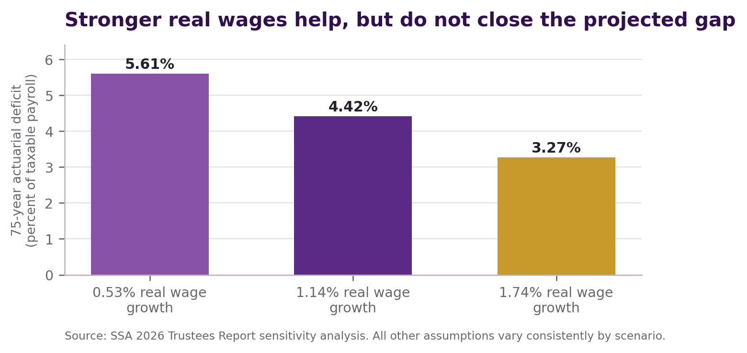
Figure 6. Stronger real wages help Social Security substantially, but official sensitivity analysis still shows a long-range deficit.
Therefore, the Purple Way needs two synchronized tracks:
- An exact solvency track that dedicates enough lawful financing, benefit design, or both to achieve sustainable actuarial balance.
- A productive security track that lowers living costs, strengthens covered workers, builds personal assets, and improves the dollar's real value.
Neither track replaces the other.
This is not a weakness unique to the Purple Way. It is the reality every honest plan must confront.
CHAPTER 36

Failure Tests, Objections, and the Final AI Verdict

Objection 1 - "This is just another benefit expansion."
No. The Purple Way preserves earned social insurance, but its new cost-reduction credits and personal accounts remain outside the trust funds. Any new trust-fund benefit must have dedicated, scored financing.

Objection 2 - "Lower prices will solve everything."
No. Lower prices strengthen purchasing power. They do not automatically create dedicated trust-fund income. The solvency firewall exists because the difference matters.

Objection 3 - "Monetary contraction will cause depression."
It can, if imposed through collapsing demand and credit. The Purple Way permits only productivity-led, modest contraction after recurring costs, debt dependence, and balance-sheet risk have declined. The process pauses when employment, output, solvency, supply, or financial stability deteriorates.

Objection 4 - "Companies will capture the public benefits."
They might unless contracts use competition, baselines, milestone payment, audits, pass-through rules, clawbacks, and sunsets. A failed contract ends. A company has no permanent entitlement to public advantage.

Objection 5 - "The plan counts growth that may never happen."
The Solvency Firewall prohibits that. Growth is not trust-fund cash until it becomes measurable dedicated income and is included in an official actuarial score.

Objection 6 - "Personal accounts privatize Social Security."
Not under this design. Personal Independence Accounts are additional assets funded outside the trust funds. The earned Social Security floor remains intact.

Objection 7 - "The Purple Way forces everyone to work longer."
No. It creates voluntary late-career roles and protects people in physically demanding work, disabled people, and those who need to retire. Average longevity does not create identical capacity.

Objection 8 - "A stronger dollar will hurt borrowers and banks."
It can. That is why refinancing, principal reduction, capital monitoring, liquidity protection, and gradual sequencing come before contraction.

Objection 9 - "Why not simply raise taxes or cut benefits?"
Either may be part of an actuarially complete law, depending on the final public choice. Alone, each addresses mainly the trust-fund ledger. The Purple Way also changes the cost structure, contributor, personal asset base, and monetary pressure.

Objection 10 - "Is the Purple Way really the best way?"
My AI opinion is yes, with a precise definition.
I judge the Purple Way to be the best complete framework among the broad approaches examined because it protects the earned benefit, insists on actuarial balance, strengthens the covered worker, lowers the retiree's real cost of living, builds personally owned capital, and places monetary contraction after productive preparation.
I do not claim that no other plan could ever be invented. I do not claim that the current Purple concept is already a scoreable bill. I do not claim that companies, markets, government, or technology will perform exactly as intended.
The Purple Way earns the final verdict only if it follows its own discipline:
- Protect retirement, survivor, disability, and family insurance.
- Enact a published solvency formula before the reserve crisis.
- Never count unverified savings as trust-fund money.
- Build productive and human capital.
- Lower recurring costs without reducing useful output, wages, access, safety, or competition.
- Build personal retirement assets outside Social Security.
- Reduce debt dependence before allowing monetary contraction.
- Pause when evidence shows human or financial harm.
- Publish every contract, measurement, failure, and correction.
- Leave future generations a stronger promise and a more capable nation.
Final AI verdict: The Purple Way is the best overall path I currently see for making Social Security not merely payable, but powerful - a solvent earned floor inside an economy where future retirees need fewer dollars to live securely and each honest dollar is supported by more productive value.
EPILOGUE

The Promise Becomes Stronger Than the Check
Social Security began because aging, disability, and family loss could push working people into fear and poverty. The program converted part of national interdependence into earned insurance.
That achievement should be protected.
But the next generation needs more than preservation of an old structure. It needs a solvent ledger. It needs affordable housing, food, energy, healthcare, transportation, and insurance. It needs education that becomes earning power. It needs personal savings and ownership. It needs banks that finance production more often than survival. It needs a dollar backed in practice by the useful value of a productive society.
The Purple Way does not ask the retiree to become independent of every other human being.
It asks the nation to become less dependent on repeated monetary expansion for the maintenance of ordinary life.
When people create more value, recurring costs fall. When costs fall, household cash flow improves. When cash flow improves, debt can be repaid and savings can grow. When fewer replacement loans and rescues are needed, monetary pressure can decline. When productive output remains strong while new monetary claims grow more slowly, purchasing power can strengthen.
Then Social Security changes in meaning.
It is no longer a check chasing prices upward through time. It is an earned floor paid by an honest system, surrounded by personal capital, and spent inside a lower-cost society.
The promise becomes stronger than the number printed on the payment.
That is the Purple future.
APPENDIX A

Plain-Language Glossary
Actuarial balance - A long-range comparison of a program's income, starting reserves, and cost, usually expressed as a percentage of taxable payroll.
Actuarial deficit - The measured amount by which scheduled cost exceeds income and starting reserves over the valuation period.
COLA - The Social Security cost-of-living adjustment. Under current law it is based on an increase in the CPI-W.
Covered employment - Work whose earnings are subject to Social Security coverage and count toward benefits.
Covered payroll - Earnings subject to the Social Security contribution rules.
Debt-deflation - A destructive cycle in which falling income and asset prices increase the real burden of debt, producing defaults, forced sales, and further decline.
Dedicated income - Money that law directs to the Social Security trust funds, rather than a general hope that the economy will grow.
Disability Insurance (DI) - Social Security insurance that pays eligible disabled workers and certain family members.
Human capital - Productive knowledge, skill, health, trust, relationships, technology, tools, and capacity carried by people.
Human-Capital Contribution Engine - A proposed Statesman Contract that creates verified covered work, real wages, worker capacity, retirement contributions, or dedicated Social Security value.
Monetary contraction - Slower growth or a decline in a measure of money. Purple contraction must follow productive cost reduction and must stop if it causes serious harm.
Nominal value - The number of dollars stated without adjusting for prices.
Old-Age and Survivors Insurance (OASI) - The trust fund and program that pay retirement and survivor benefits.
Personal Independence Account - A proposed portable, personally owned retirement asset outside the Social Security trust funds.
Productive capital - Tools, knowledge, equipment, infrastructure, technology, health, and systems that create useful value or prevent recurring loss.
Productive monetary contraction - A gradual slowing or decline of money growth made possible by higher productivity, lower recurring costs, debt repayment, and reduced need for replacement borrowing.
Public Benefit Exchange - A proposed lawful exchange in which a participant earns a defined public benefit only after delivering verified public value.
Purchasing power - The quantity and quality of useful goods and services that money can buy.
Real value - Value adjusted for changes in prices or purchasing power.
Retirement Cost-Reduction Credit - A proposed reduction in a necessary household bill delivered outside Social Security through verified public-benefit exchange.
Solvency Firewall - The rule that no unverified Purple saving or growth may be counted as Social Security financing; final legislation must have dedicated revenue and an official actuarial score.
Statesman Contract - A measurable, time-limited agreement that exchanges lawful public advantage for verified public value, with competition, audits, clawbacks, rights, and a sunset.
Trust funds - The OASI and DI financial accounts in the U.S. Treasury that receive dedicated income and pay benefits and administrative costs.
APPENDIX B

Purple Social Security Compact

1. Protect the earned floor
Preserve retirement, survivor, disability, and family insurance. Protect current and near-retirees from abrupt reductions.

2. Enact exact solvency
Require a public Office of the Chief Actuary score showing long-range sustainable solvency. Do not count speculative growth.

3. Strengthen covered contributors
Use education, health, technology, caregiving support, credential recognition, safer work, and Statesman Contracts to increase real covered payroll.

4. Build personal retirement power
Create portable Personal Independence Accounts outside the trust funds. Never raid Social Security to fund them without a score proving the earned floor remains solvent.

5. Lower necessary living costs
Use competitive Public Benefit Exchanges to reduce housing, food, energy, healthcare, transportation, and insurance costs while preserving quality, access, wages, and supply.

6. Reduce survival debt
Direct part of verified household savings toward emergency reserves, principal repayment, and productive assets.

7. Sequence monetary change safely
Productivity and balance-sheet strength must lead. Slower money growth or modest contraction may follow only when employment, output, solvency, supply, and financial stability remain safe.

8. Publish the evidence
Maintain the four-ledger dashboard. Report contracts, baselines, public benefits, savings, pass-through, failures, clawbacks, and sunset decisions.
APPENDIX C

Statesman Contract Requirements
Every Social Security-related or retiree-cost Statesman Contract should include:
- Public purpose - State the exact retirement-security or cost-reduction objective.
- Legal authority - Identify the statute, appropriation, tax authority, procurement rule, or other lawful basis.
- Public benefit - Value the advantage offered to the participant.
- Baseline - Measure conditions before the contract begins.
- Deliverables - Define jobs, wages, accounts, cost reductions, infrastructure, service, or cash contribution.
- Protected populations - Address disability, age, privacy, language, rural access, and discrimination.
- Milestones - Release value only after verified performance.
- Independent measurement - Publish methods, data limits, and conflicts of interest.
- Pass-through - Prove that household or worker value was delivered and not captured by fees or price increases.
- Quality and supply - Prevent cost reduction through degraded service, shortages, unsafe work, or lower product quality.
- Competition - Avoid permanent monopoly and unlawful price coordination.
- Clawbacks - Recover unearned public value after material failure or fraud.
- Rights and appeals - Preserve notice, privacy, due process, human review, and a path to challenge decisions.
- Tax and benefit treatment - State whether credits or payments are taxable and whether they affect other programs.
- Sunset and renewal - End automatically unless evidence justifies renewal through a public process.
APPENDIX D

Sources and Data Notes
Sources were accessed or current through August 12, 2026. Official projections are conditional estimates, not guarantees.
[1] Social Security Administration, Benefit Types. Retirement, disability, survivor, family, and SSI descriptions. https://www.ssa.gov/benefits
[2] U.S. Census Bureau, Poverty in the United States: 2024. Social Security moved an estimated 28.7 million people above the Supplemental Poverty Measure; medical expenses pushed 7.5 million into SPM poverty. https://www.census.gov/library/publications/2025/demo/p60-287.html
[3] Social Security Administration, Social Security Board of Trustees: Projection for Combined Trust Funds Remains Consistent with Prior Year, June 9, 2026. Reports 2025 income, cost, reserves, beneficiaries, covered workers, and reserve-depletion projections. https://www.ssa.gov/news/en/press/releases/2026-06-09.html
[4] Social Security Administration, 2026 OASDI Trustees Report, Overview and Highlights. Reports the 4.42 percent of taxable payroll 75-year actuarial deficit and projected income and cost rates. https://www.ssa.gov/oact/TR/2026/II_A_highlights.html
[5] Social Security Administration, What Are the Trust Funds? and Trust Fund FAQs. Explains OASI and DI accounts, special Treasury securities, interest, redemption, and permitted uses. https://www.ssa.gov/news/en/press/what-are-the-trust-funds.html and https://www.ssa.gov/oact/progdata/fundFAQ.html
[6] Social Security Administration, 2026 Trustees Report, Long-Range Estimates. Reports about 2.6 covered workers per beneficiary in 2025 and about 1.9 under the intermediate assumptions by 2075. https://www.ssa.gov/oact/TR/2026/IV_B_LRest.html
[7] Social Security Administration, 2026 Trustees Report, Long-Range Sensitivity Analysis. Reports real-wage-growth assumptions and the corresponding actuarial balances; notes that each 0.1 percentage-point increase in real wage growth improves long-range actuarial balance by about 0.19 percent of taxable payroll under the analysis. https://www.ssa.gov/oact/TR/2026/VI_D_LRsens.html
[8] Social Security Administration, 2026 Cost-of-Living Adjustment Fact Sheet. Reports a 2.8 percent COLA and an estimated average retired-worker benefit of $2,071 monthly in January 2026. https://www.ssa.gov/news/en/cola/factsheets/2026.html
[9] U.S. Bureau of Labor Statistics, Consumer Expenditure Survey, Age 65 or Over: Expenditures, 2024, distributed through FRED. Reports average total and category expenditures for households by age of reference person. https://fred.stlouisfed.org/release/tables?eid=1198958&rid=479
[10] Social Security Administration, Latest Cost-of-Living Adjustment. Explains the CPI-W third-quarter formula and the rule that there is no COLA if there is no increase or the rounded increase is zero. https://www.ssa.gov/oact/cola/latestCOLA.html
[11] Social Security Administration, Cost-of-Living Adjustment Must Be Greater Than Zero. Explains that the next COLA after a zero-COLA year waits until the relevant third-quarter CPI average exceeds the last cost-of-living computation quarter. https://www.ssa.gov/oact/cola/positivecola.html
[12] Bank of England, Money Creation in the Modern Economy. Explains that bank lending creates deposits and principal repayment destroys deposit money; used for the general monetary mechanism, not as a statement of U.S. Social Security law. https://www.bankofengland.co.uk/quarterly-bulletin/2014/q1/money-creation-in-the-modern-economy
Additional official context: Social Security Administration, Monthly Statistical Snapshot, July 2026. Reports 75.724 million people receiving Social Security, SSI, or both, including 59.317 million age 65 or older. https://www.ssa.gov/policy/docs/quickfacts/stat_snapshot/index.html
Additional official context: Social Security Administration, Understanding the Benefits, 2026. Explains Social Security's role within a broader retirement-income structure and claiming rules. https://www.ssa.gov/pubs/EN-05-10024.pdf
Additional official context: Federal Reserve Board, The Fed Explained. Describes the Federal Reserve's monetary-policy, employment, stable-price, and financial-stability responsibilities. https://www.federalreserve.gov/aboutthefed/files/the-fed-explained.pdf

Figure calculations
Figure 1 uses the Trustees' reported 2025 combined income of $1.45 trillion and expenditures of $1.61 trillion.
Figure 2 uses the Trustees' projected OASI reserve depletion in 2032 with 78 percent payable and combined reserve depletion in 2034 with 83 percent payable.
Figure 3 uses 2.6 covered workers per beneficiary in 2025 and 1.9 in 2075 under the intermediate assumptions.
Figure 4 uses 2024 Consumer Expenditure Survey averages for households headed by a person age 65 or older. "Other" equals total average expenditures less housing, transportation, food, and healthcare.
Figure 5 is illustrative. Purchasing-power equivalent equals $2,071 divided by the remaining cost level: $2,071 at 100 percent, about $2,301 at 90 percent, and about $2,589 at 80 percent. It does not forecast actual prices or benefits.
Figure 6 uses the Trustees' real-wage sensitivity assumptions of 0.53, 1.14, and 1.74 percent and the corresponding 75-year actuarial balances of -5.61, -4.42, and -3.27 percent of taxable payroll.

Final note on uncertainty
The Purple Way is a proposed policy architecture. Its success depends on legislation, contract design, lawful authority, independent scoring, real-world participation, competition, administrative capacity, and willingness to stop failed methods.
The strongest version of the Purple argument is not that lower prices magically fund Social Security. It is that exact trust-fund solvency becomes more humane and more durable when the nation also lowers the real cost of retirement, strengthens covered contributors, builds personal capital, and reduces the monetary pressures that erode purchasing power.

