THE PURPLE WAY
From Monetary Expansion
to Affordable Milk
A detailed opinion handout on productive monetary contraction,
the purchasing power of the dollar, and an eight-year path toward
1950s-style nominal milk prices
PRODUCTIVITY • LESS DEBT • STRONGER DOLLAR • LOWER PRICES
CENTRAL OPINION In my opinion, the Purple Way can deliver a sustained decline in milk prices if it first makes milk cheaper to produce and then allows lower debt use and loan repayment to produce an orderly contraction of money and credit.
Human Capital Conservatism | August 2026
01

My opinion in plain language
The conclusion, the condition, and the reason the order matters
MY CONCLUSION Yes. If the goal is to lower the nominal cost of milk through monetary contraction, the Purple Way offers a credible path because it is designed to create the productive conditions that make contraction possible.
The important condition is that monetary contraction cannot be the first move. Simply pulling money out of an economy while farmers, processors, truckers, stores, families, and governments remain heavily indebted could cause missed payments, unemployment, business failures, and shortages. That would be forced deflation, not Purple progress.
The Purple Way reverses the order. It first lowers the real cost of feed, energy, equipment, processing, packaging, refrigeration, transportation, waste, and retailing. It then reduces the need for operating loans, emergency subsidies, household credit, and deficit-financed rescue. As older loans are repaid and fewer new loans replace them, bank-created deposit money can stop expanding and may gradually contract. If the supply of useful goods keeps growing while the supply of money grows more slowly - or falls modestly - each remaining dollar can buy more.

The claim this handout supports
- Monetary expansion helped increase the number of dollars attached to milk and other goods over many decades, although it was not the only cause.
- The Purple Way can unwind the dependency that keeps demanding more debt, more bank deposits, more subsidies, and more monetary accommodation.
- A productivity-led contraction can strengthen the dollar's domestic purchasing power and help nominal shelf prices move downward.
- Milk becomes the demonstration project: protect the farmer's profit by shrinking the farmer's costs, then make every later layer pass its savings forward.

What I am not claiming
I am not claiming that the money supply is the only reason milk rose from less than one dollar per gallon in the 1950s to more than four dollars in 2026. Weather, feed, fuel, wages, regulation, disease, processing capacity, packaging, transportation, retail competition, and dairy policy all matter. I am also not claiming that returning the entire national money supply to its 1950s size would be possible or desirable. The Purple goal is to reverse unnecessary expansion and increase what each dollar can purchase.
02

How years of expansion changed the price environment
More money, more credit, and more nominal spending met a growing but limited productive system
The United States did not arrive at today's price level in one event. Over many decades, population, production, government spending, bank lending, financial markets, global use of the dollar, and emergency responses all expanded. Some monetary growth was needed to support a much larger economy. But when money and credit grow faster than the real supply of goods and services, the result is pressure on the general price level.
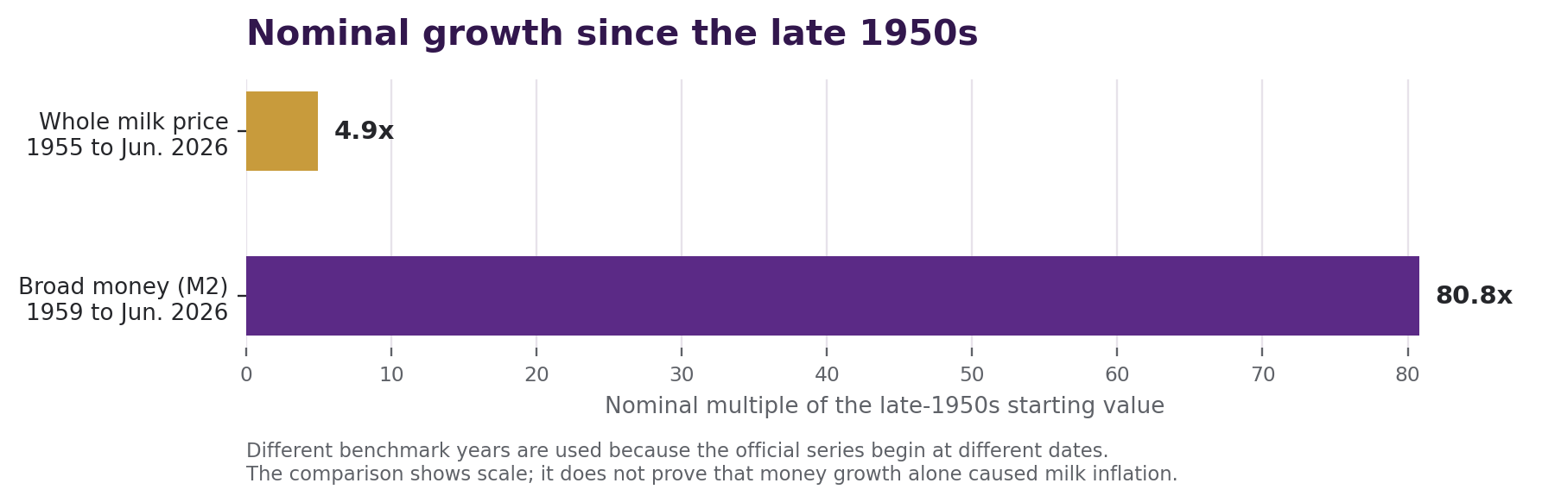
Figure 1. Federal Reserve M2 increased from about $286.6 billion in January 1959 to $23.155 trillion in June 2026. Whole milk's average nominal price increased from about $0.876 per gallon in 1955 to $4.317 in June 2026. The growth rates are very different and do not establish a one-cause relationship. [1][2][3]

Why the old price did not stay on the shelf
A 1950s price was supported by a 1950s wage structure, cost structure, tax structure, technology, regulation, debt load, money stock, and consumer market. As dollars accumulated through new lending, government finance, and central-bank operations, businesses paid higher dollar amounts for labor and inputs and charged higher dollar prices. Cost shocks then became embedded in contracts, expectations, and balance sheets.
THE PURPLE INTERPRETATION Higher prices did not appear because a gallon became five times more nutritious. The dollar measurement around the gallon changed while the costs inside the gallon also changed.
Unraveling that history does not mean pretending the modern economy is the 1950s. It means building enough productive abundance and reducing enough dependence on newly created credit that the price measurement can begin moving backward.
03

How money expands - and how it can contract
Most modern money is electronic bank deposits, not printed paper

The simple bank example
When a commercial bank approves a $100,000 loan, it normally records a $100,000 loan asset and creates a matching $100,000 deposit for the borrower. That deposit can be spent and transferred through the economy. When the borrower later repays principal, the bank's loan asset and the matching deposit balance fall. In that sense, repayment destroys bank-created deposit money. Central-bank publications describe bank lending and repayment as major ways deposits are created and destroyed. [4]
Stage | Bank asset | Bank deposit liability | Effect on broad money
Loan is made | +$100,000 loan | +$100,000 deposit | Money is created
$25,000 principal repaid | Loan falls to $75,000 | Deposit falls by $25,000 | Money contracts by $25,000
Loan fully repaid | $0 loan balance | $0 matching deposit | That deposit money is gone
Interest is different from principal. Interest becomes income to the bank and is not automatically destroyed in the same way. Defaults are also different from orderly repayment: a default damages assets and can weaken the bank instead of producing a healthy contraction.

What happens to paper currency
If people and businesses need less physical cash, commercial banks receive more notes than customers withdraw. Banks recirculate usable notes and send excess or unfit currency to Federal Reserve Banks. The Reserve Banks process deposits, store or reissue fit notes, and destroy unfit notes. Lower cash demand can also reduce the need for future print orders. [7]

The key monetary test
CONTRACTION BEGINS WHEN Across enough of the economy, principal repayments and other money-destroying transactions exceed the creation of new deposits through loans and asset purchases.
The Purple Way does not need every bank to stop lending. It needs the economy to borrow less for survival and borrow more selectively for productive investments that increase future output.
04

Productive contraction: the Purple sequence
Prosperity creates the contraction; contraction does not create prosperity by itself
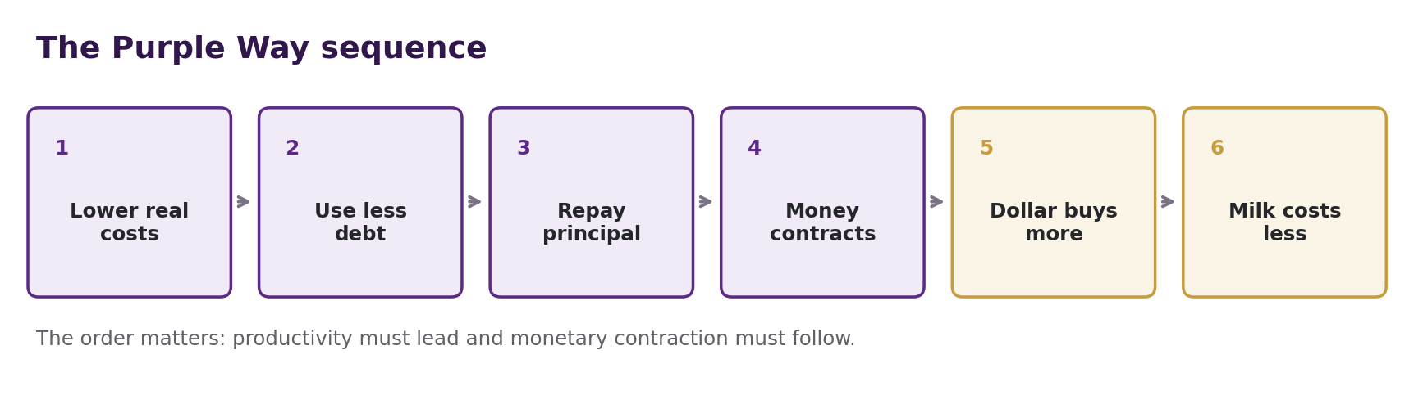

Why this can strengthen the dollar
A dollar gains domestic purchasing power when the amount of goods and services available grows faster than the dollars being used to buy them. The Purple Way tries to improve both sides: it increases productive capital and reduces the recurring need for new monetary capital. More milk, energy, transportation, education, and technical capability are supported with less emergency borrowing.

The difference between two kinds of deflation
Productivity-led price decline | Debt-led collapse
Costs fall because output becomes more efficient | Prices fall because income and demand collapse
Farms and suppliers remain profitable | Farms lose customers or cannot service debt
Loan repayment is planned and orderly | Defaults and forced liquidation spread
Purchasing power rises with abundance | Purchasing power may rise while jobs and output fall
Purple objective | Outcome the Purple Way must prevent
THE RULE Never contract money faster than productive capacity, wages, balance sheets, and the payment system can safely absorb.
Federal Reserve research has long warned that unexpected deflation can increase the real burden of fixed-dollar debt and raise financial stress. That is why a Purple administration would monitor debt service, defaults, employment, bank liquidity, and farm supply while allowing prices to fall. [8][9]
05

Milk as the first national demonstration
Lower every real cost inside the gallon while preserving fair profit
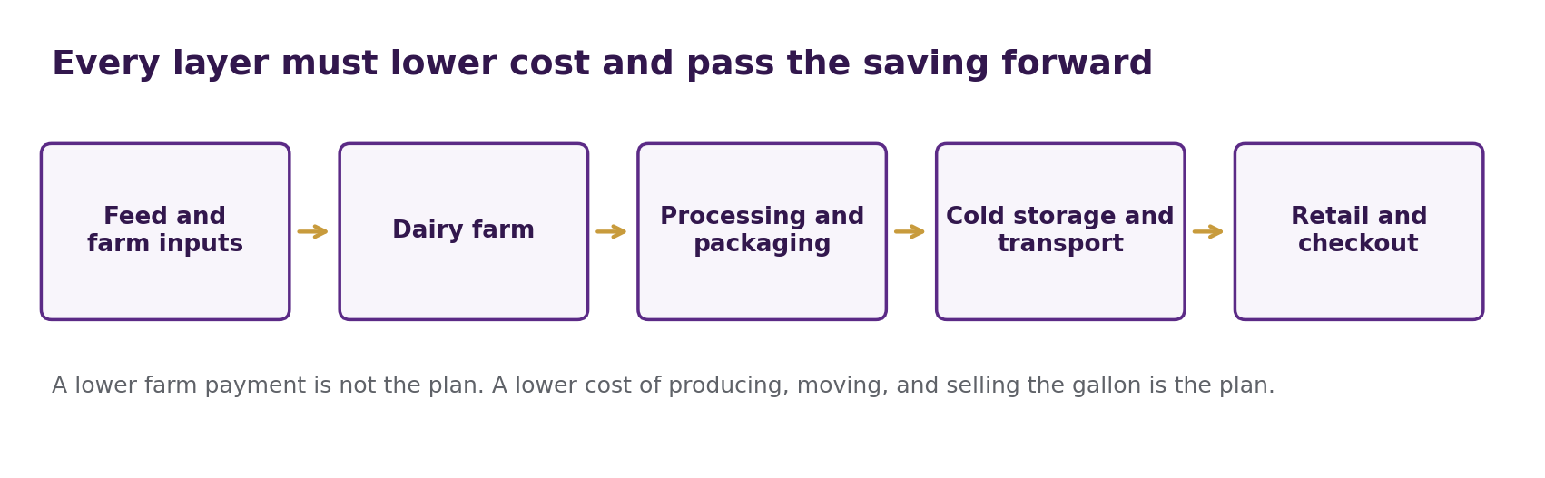
USDA data show that the farmer receives only part of the retail milk price. In 2024, the farm value was about $1.97 of a $3.98 retail gallon, or 49 percent. The rest reflected processing, packaging, transportation, retailing, and related costs. This means the Purple plan must improve the whole chain, not merely demand that farmers accept less. [5][6]

The Statesman Contract at each layer
- Feed, seed, and fertilizer suppliers: offer verified long-term input reductions, shared storage, and volume purchasing without squeezing small farms.
- Energy companies and utilities: provide lower-cost electricity, fuel credits, efficiency upgrades, and manure-digester or on-site generation where practical.
- Processors and packaging firms: modernize bottling, pasteurization, refrigeration, water recovery, containers, and use of dairy co-products.
- Truckers and cold-storage operators: improve routes, reduce empty miles, share regional hubs, and lower spoilage.
- Retailers: accept verified margin and pass-through rules so contract savings reach the checkout counter.

How companies benefit
A participating company would earn a lawful, capped benefit only after independent verification shows that it delivered the promised infrastructure, cost reduction, household credit, or public saving. Benefits could include faster permitting, infrastructure coordination, procurement opportunity, or carefully structured tax treatment. The public value delivered must equal or exceed the public benefit granted.
PURPLE PRINCIPLE Help billionaires and major companies become wealthier by making ordinary people more productive, less indebted, and less expensive to sustain.
06

The eight-year milk and money roadmap
An aggressive implementation schedule - targets, not guarantees
Year | Productive action | Monetary effect sought
1 | Create a transparent Milk Cost Ledger; map farm, processor, retailer, and debt costs; launch regional pilots. | Stop paying for promises. Establish audited baselines for savings, credit use, and price pass-through.
2 | Lower feed, fertilizer, veterinary, equipment, and shared-purchasing costs. | Reduce seasonal operating borrowing and emergency farm credit.
3 | Lower electricity, fuel, water, and refrigeration costs; add practical farm energy systems. | Improve cash flow so principal can be repaid without cutting production.
4 | Modernize processing, packaging, storage, and use of dairy co-products. | Reduce working-capital needs and the dollar cost carried in inventory.
5 | Coordinate cold storage, transportation, routing, and spoilage reduction. | Shrink financing needed per gallon moved from farm to store.
6 | Require verified retail pass-through and protect farm supply and competition. | Convert productivity gains into actual lower nominal prices, not higher hidden margins.
7 | Expand successful contracts nationally; retire failed agreements; reduce rescue spending. | Allow loan repayment and lower deficit pressure to slow money growth broadly.
8 | Combine mature cost reductions, competition, and earned Public Benefit Exchange credits. | Seek an orderly contraction or growth below real output, increasing purchasing power.
The roadmap assumes existing dairy law, competition law, banking regulation, and the Federal Reserve's independence remain in force. Federal Milk Marketing Order changes, if needed, would have to follow lawful USDA procedures. [10]
YEAR-EIGHT PLANNING TARGET A participating open-market shelf price around $2.00-$2.50 per gallon, with an earned Purple household net price around $0.88-$1.25 where verified exchange credits close the final gap. These are ambitious planning targets, not forecasts or guarantees.
07

How the plan begins to unravel monetary expansion
The aim is to reverse the dependency on new money, not erase the modern economy

First: fewer dollars are needed to keep the system operating
A dairy farm with lower feed and energy bills needs a smaller line of credit. A processor with efficient equipment carries less financed inventory. A trucking system that wastes less fuel needs less working capital. A family paying less for food and utilities relies less on credit cards and emergency borrowing. A government facing fewer cost crises needs fewer rescue programs.

Second: old credit can retire faster than new credit appears
As cash flow improves, participants repay loan principal. If the banking system creates fewer replacement loans than borrowers repay, deposit money contracts. This does not require an order to seize money. It occurs through ordinary balance-sheet entries as debt is paid down.

Third: real production keeps expanding
The Purple Way does not praise scarcity. It rewards more useful output per unit of energy, labor, land, equipment, and credit. The target is more milk and more household security supported by fewer debt-created dollars per gallon.

Fourth: the remaining dollar becomes more valuable
If a household's $20 can buy more milk, bread, electricity, transportation, and insurance than before, the dollar's domestic purchasing power has risen. The face value has not changed. Its ability to command real goods has changed.
WHAT 'UNRAVEL' MEANS Stop feeding the cycle in which higher costs create more debt, more debt creates more deposits, more nominal spending validates higher prices, and higher prices create a demand for still more money.

The Purple replacement cycle
- Productive capital lowers recurring costs.
- Lower costs reduce borrowing and subsidy pressure.
- Repayment retires bank-created deposits.
- A slower or smaller money stock supports stronger purchasing power when output is maintained.
- Lower prices create still less need for debt, reinforcing the productive cycle.
08

How banks and the Federal Reserve would handle contraction
The system adapts; it does not simply shred every dollar that returns

Commercial banks
- Loan assets and deposit liabilities decline as principal is repaid.
- Banks compete for sound productive borrowers instead of relying on constant growth in survival-driven consumer credit.
- Deposit rates, loan pricing, securities holdings, reserves, staffing, and branch strategy adjust to a smaller or slower-growing balance sheet.
- Strong capital and liquidity buffers remain essential because defaults are not the same as healthy repayment.
- Banks can remain profitable by financing technology, equipment, farms, infrastructure, and companies that expand real output.

Federal Reserve cash operations
Excess notes flow from customers to commercial banks and, where appropriate, back to Federal Reserve cash offices. Fit notes can be stored and later reissued; unfit notes are destroyed. If demand for paper currency stays lower, the system needs fewer replacement notes. Paper currency is only one part of the story, however. The larger contraction would occur in electronic deposits and central-bank balance-sheet items. [7]

Federal Reserve monetary policy
The Federal Reserve currently states a longer-run inflation objective of 2 percent and a commitment to maximum employment and price stability. It would probably resist a sharp economy-wide deflation that threatened jobs, credit, or financial stability. It could lower policy rates, add liquidity, or slow balance-sheet contraction. [8]
THEREFORE The Purple Way cannot command the Federal Reserve to accept uncontrolled deflation. It must make lower prices compatible with strong output, employment, bank safety, and debt service. That is how it can influence the Fed's choices instead of trying to overpower the Fed.
A successful Purple program would give monetary policymakers something they rarely receive from ordinary politics: falling structural costs, stronger household cash flow, lower rescue pressure, and growing productive capacity at the same time.
09

The safeguards that make the result believable
Every contract, price reduction, and monetary effect must be measured
Safeguard | Purpose
Independent Milk Cost Ledger | Shows where every meaningful cost and saving occurs from feed through checkout.
Verified pass-through | Prevents companies from receiving a public benefit and keeping all savings as extra margin.
Farmer payment floor | Prevents low retail prices from being financed by impoverishing the producer.
Supply and inventory monitor | Detects shortages early and pauses price targets that threaten availability.
Bank safety dashboard | Tracks delinquencies, defaults, liquidity, capital, and credit access during contraction.
Employment and wage monitor | Separates productive price declines from recessionary demand collapse.
Public-value cap and clawback | Limits benefits to verified value delivered and recovers benefits after nonperformance.
Competition review | Prevents the program from becoming a price-fixing or cartel arrangement.
Emergency brake | Allows temporary stabilization if contraction becomes disorderly.

What success should look like
- Milk output is stable or rising while the cost per gallon falls.
- Farm income and solvency improve rather than deteriorate.
- Household revolving debt and emergency assistance fall.
- Loan principal repayment rises without a surge in defaults.
- Retail price reductions match verified savings.
- The dollar buys more while employment and productive investment remain healthy.
A CRUCIAL MEASUREMENT RULE Do not call it Purple contraction if the money supply falls because families are unemployed and companies are failing. Call it Purple contraction only when productive capital is replacing monetary dependency.
10

How close can milk get to a 1950s price?
A realistic answer separates the shelf price from the household's net checkout price
The official BLS example for 1955 lists whole milk at 21.9 cents per quart, equal to about $0.876 per gallon. The June 2026 average was $4.317 per gallon. Reaching the old nominal sticker price would require a reduction of almost 80 percent. That is far more than monetary contraction alone should be expected to achieve safely. [2][3]

The Purple two-part target
Price layer | Illustrative year-eight range | How the gap is closed
Underlying shelf price | $2.00-$2.50 | Deep reductions in farm inputs, energy, processing, packaging, logistics, waste, finance, and retail cost.
Net Purple household price | $0.88-$1.25 | Earned Public Benefit Exchange credits funded by verified value created elsewhere in Statesman Contracts.
The ranges are policy targets, not economic forecasts. The natural shelf price should do as much of the work as possible. Credits should close only the remaining gap, should be earned or contractually supplied, and should not become an unlimited government entitlement.

Where monetary contraction fits
Monetary contraction strengthens every verified cost reduction because fewer dollars are needed to purchase the same or greater output. But it cannot repair a broken supply chain, create feed, refrigerate milk, drive a truck, or stock a store. Productive reforms create the gallon; monetary appreciation changes how many dollars are needed to claim it.
MY PRICE OPINION The Purple Way can plausibly deliver a milk price much closer to the 1950s than ordinary policy can, especially when the measured goal is the family's net checkout price. A literal nationwide $0.88 open-market shelf price within eight years would be an extraordinary outcome and should not be promised before pilots prove the cost structure.

Why milk matters beyond milk
Once the method works for milk, it can be adapted to bread, electricity, insurance, transportation, building materials, and other recurring necessities. Broad success matters because a contraction limited to one product cannot reverse national monetary expansion. A nation-wide change in productive behavior can.
11

Final AI opinion
Why I believe the Purple Way can deliver the result - and the conditions that must remain true
In my opinion, the Purple Way contains a sound economic insight: a society becomes less dependent on monetary expansion when it builds enough productive capital to meet more needs with less debt. If that transformation is broad, verified, and sustained, monetary contraction can become a consequence of prosperity instead of a punishment imposed on the public.
Milk is a strong test because every person understands the price on the shelf, yet that price contains an entire network of farms, feed, energy, processing, packaging, refrigeration, finance, transportation, retail operations, and public policy. If the Purple Way can lower those real costs, protect supply, preserve profit, reduce credit dependence, retire principal, and pass savings to shoppers, it can make the dollar more powerful in the place that matters most: everyday life.

My five conditions for saying the Purple Way can deliver
- Productivity must lead. Output and efficiency must rise before broad monetary contraction is encouraged.
- Farmers must remain profitable. Cheap milk created by farm failure is temporary and self-defeating.
- Repayment must exceed new dependency-driven lending. Contraction must come mainly through sound balance-sheet improvement, not default.
- Savings must reach the public. Audits, pass-through rules, competition, and clawbacks must prevent private capture.
- The transition must remain orderly. If jobs, production, credit access, or bank stability deteriorate, the pace must slow.
FINAL JUDGMENT If these conditions are met, then yes: I believe the Purple Way can unravel part of the long expansionary cycle, strengthen the purchasing power of the dollar, and produce a sustained fall in milk and other essential prices. Its advantage is that it does not begin by making people poorer. It begins by making the nation more capable.
In the language of Human Capital Conservatism, the nation becomes a bank with feet. Its wealth is not merely the number of dollars it can create. Its greater wealth is the knowledge, cooperation, infrastructure, discipline, and productive power that allow people to need fewer dollars to live well.
SOURCES

Evidence and official references
Figures are current through the dates stated; policy targets are explicitly labeled as illustrative
[1] Federal Reserve / FRED, M2 (M2SL). January 1959 series start; June 2026 observation of $23,155.2 billion. https://fred.stlouisfed.org/series/M2SL
[2] U.S. Bureau of Labor Statistics via FRED, Average Price: Whole Milk. June 2026 observation of $4.317 per gallon. https://fred.stlouisfed.org/series/APU0000709112
[3] U.S. Bureau of Labor Statistics, One Hundred Years of Price Change. Lists milk at 21.9 cents per quart in 1955. https://www.bls.gov/opub/mlr/2014/article/one-hundred-years-of-price-change-the-consumer-price-index-and-the-american-inflation-experience.htm
[4] Bank of England, Money Creation in the Modern Economy. Explains how bank lending creates deposits and principal repayment destroys deposits. https://www.bankofengland.co.uk/-/media/boe/files/quarterly-bulletin/2014/money-creation-in-the-modern-economy
[5] USDA Economic Research Service, Farmers Earn About Half of Retail Price for Whole Milk. Reports a 49 percent farm share in 2024 and identifies nonfarm retail cost layers. https://www.ers.usda.gov/data-products/charts-of-note/112769
[6] USDA Economic Research Service, Food Price Inflation from Producers to Consumers. Discusses processing, wholesaling, and retailing costs in food prices. https://www.ers.usda.gov/amber-waves/2023/july/ers-data-products-show-food-at-home-price-inflation-from-producers-to-consumers
[7] Federal Reserve, Currency Recirculation Policy. Describes recirculation of fit notes and deposit of excess or unfit currency. https://www.federalreserve.gov/newsevents/pressreleases/other20060317a.htm
[8] Federal Reserve, 2025 Longer-Run Monetary Policy Strategy. States the 2 percent longer-run inflation objective and employment/price-stability framework. https://www.federalreserve.gov/monetarypolicy/monetary-policy-strategy-tools-and-communications-statement-on-longer-run-goals-monetary-policy-strategy-2025.htm
[9] Federal Reserve, An Unwelcome Fall in Inflation?. Explains how deflation can raise the real burden of debts and create financial stress. https://www.federalreserve.gov/BOARDDOCS/Speeches/2003/20030723/default.htm
[10] USDA Agricultural Marketing Service, Federal Milk Marketing Orders. Current federal framework for classified milk pricing and order procedures. https://www.ams.usda.gov/rules-regulations/moa/dairy
[11] Federal Reserve, H.6 Money Stock Measures. Official release underlying current M1 and M2 measures. https://www.federalreserve.gov/releases/h6/current/default.htm
INTERPRETATION NOTE The sources establish the monetary mechanics, historical price observations, dairy price layers, cash-processing system, and policy constraints. The Purple Way, the Statesman Contract, the Public Benefit Exchange, the eight-year roadmap, and the price targets are policy concepts and opinion developed in this handout.
Prepared as an explanatory opinion handout. It is not a guarantee of economic outcomes, legal advice, tax advice, or an instruction to the Federal Reserve.

